1. **TRELLO_ACTION_GET_BOARD_BY_ID_ACTION**

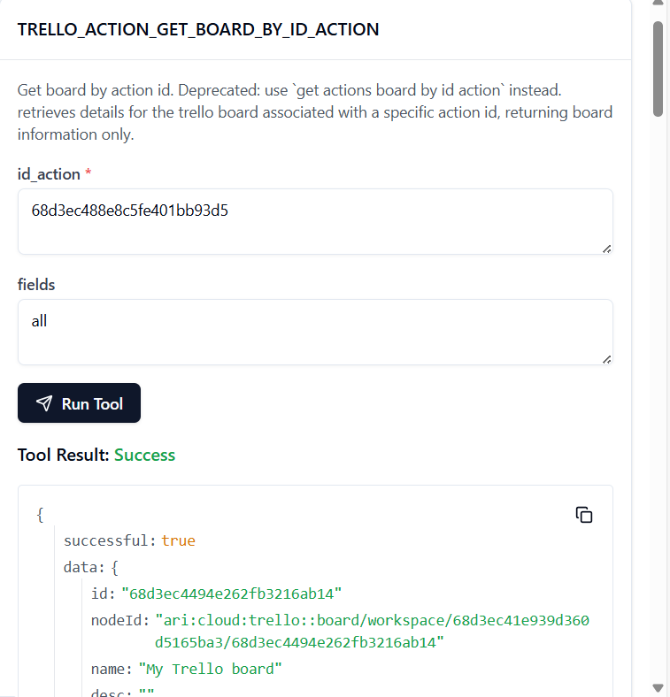

TO GET THE BOARD ID:

<https://api.trello.com/1/boards/68d3ec4494e262fb3216ab14?key=0e25f87141aa66e3d5d9116f606c989d&token=ATTA703ac75455c2e1835e473d2868aededa8de3f9bce180293b1331718b048edef4752AA41F>

TO GET THE ACTION ID:

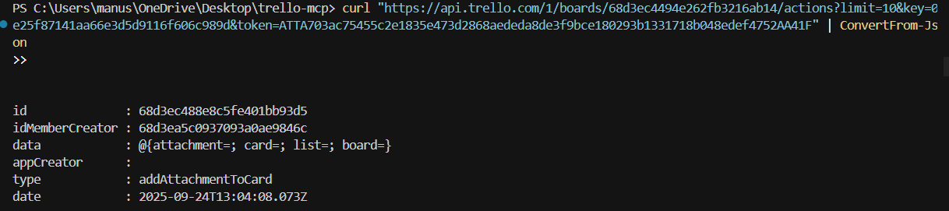

2. **TRELLO_ACTION_GET_BY_ID**

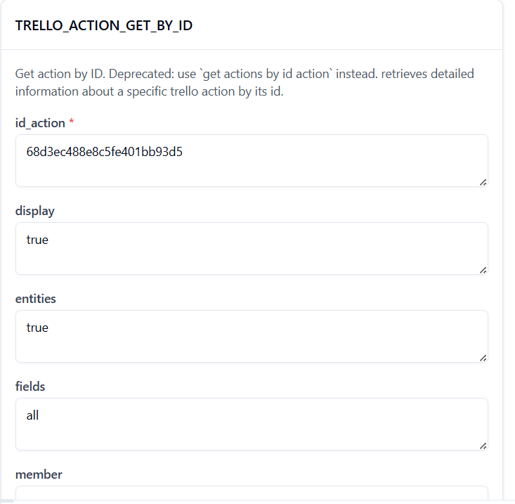

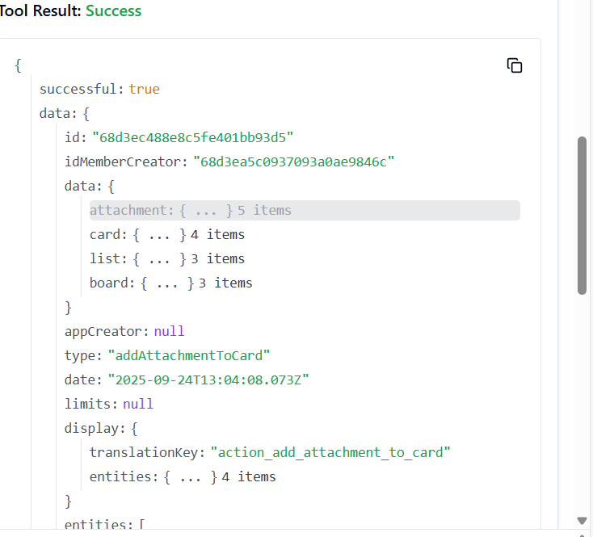

3. **TRELLO_ACTION_GET_LIST_BY_ID_ACTION**

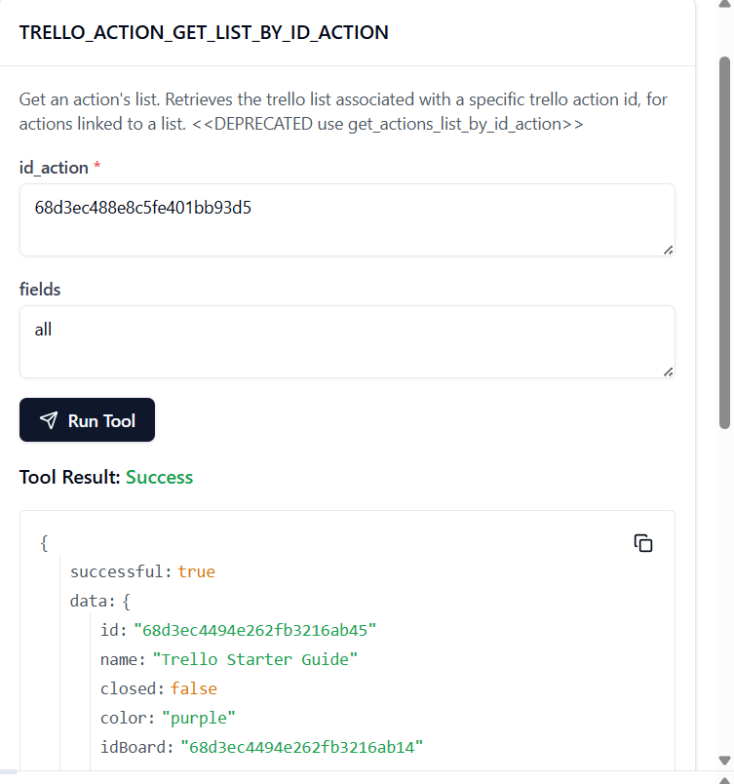

4. **TRELLO_ADD_BOARDS**

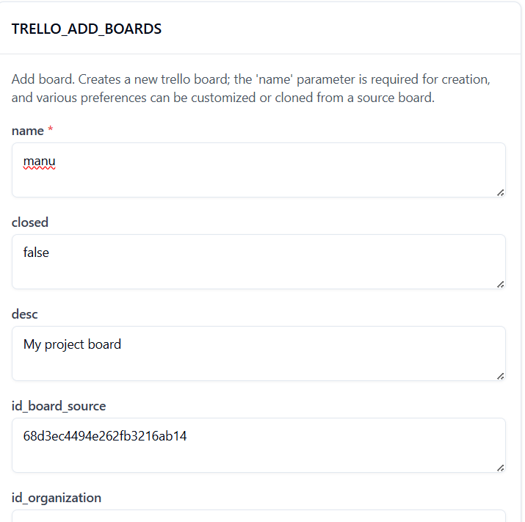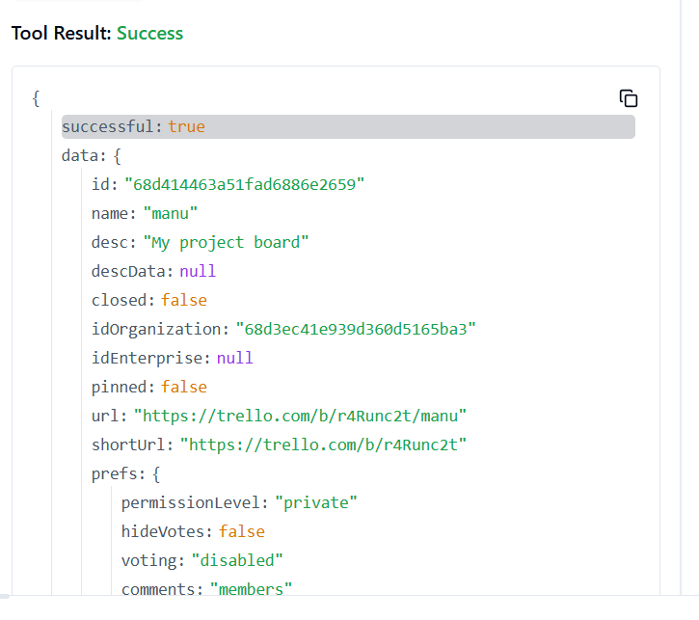

5. **TRELLO_ADD_BOARDS_CALENDAR_KEY_GENERATE_BY_ID_BOARD**

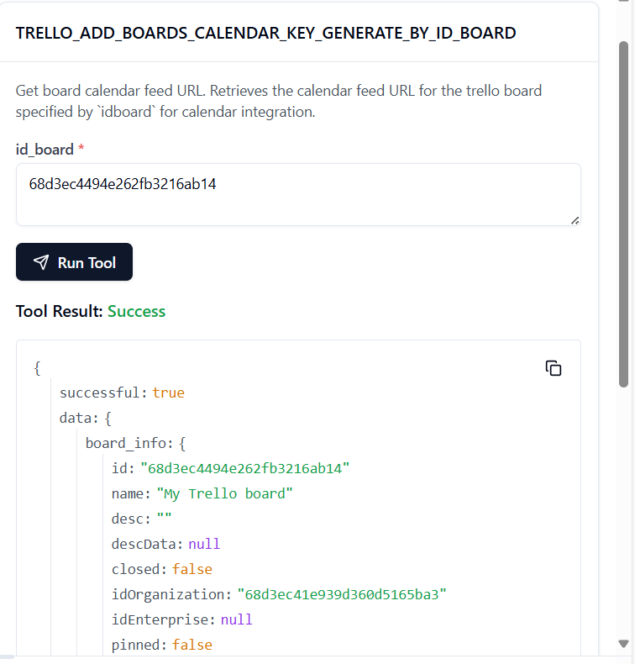

6. **TRELLO_ADD_BOARDS_EMAIL_KEY_GENERATE_BY_ID_BOARD**

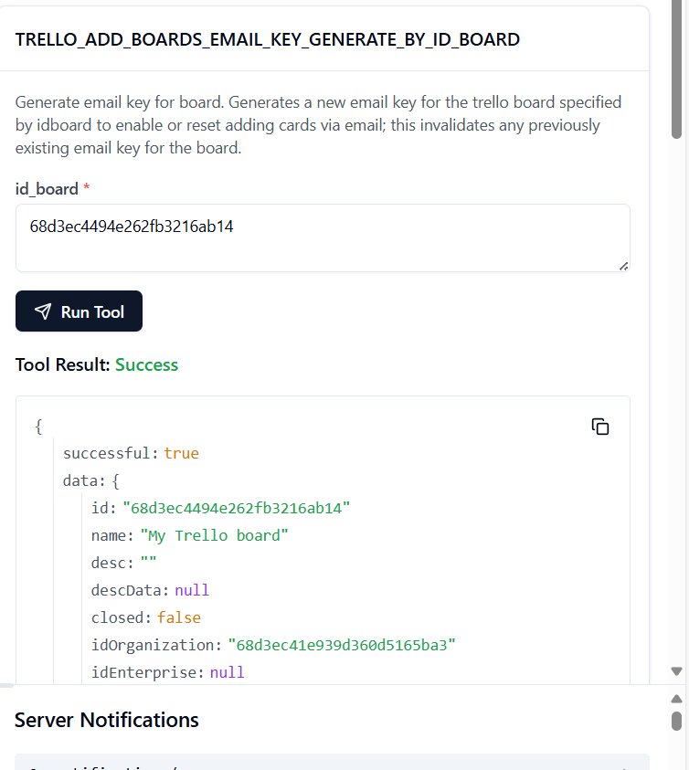

7. **TRELLO_ADD_BOARDS_LABELS_BY_ID_BOARD**

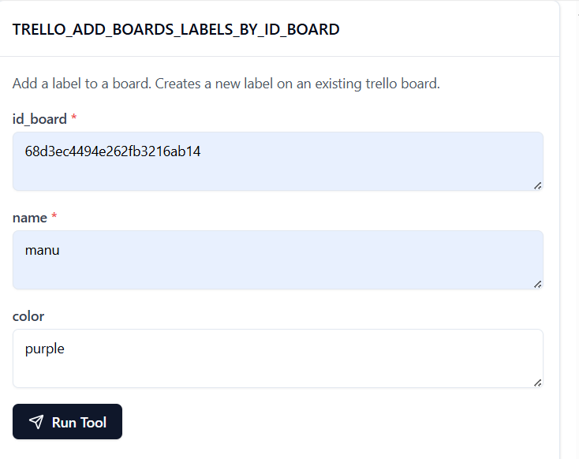

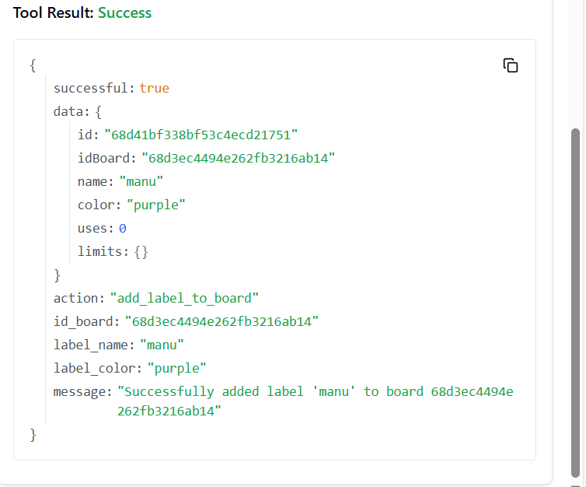

8. **TRELLO_ADD_BOARDS_LISTS_BY_ID_BOARD**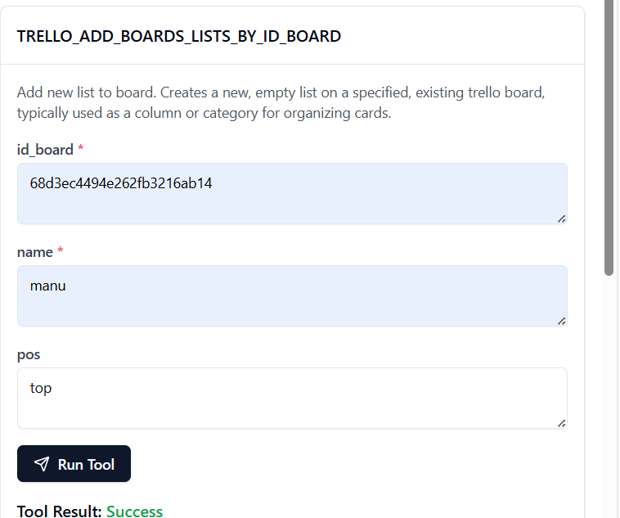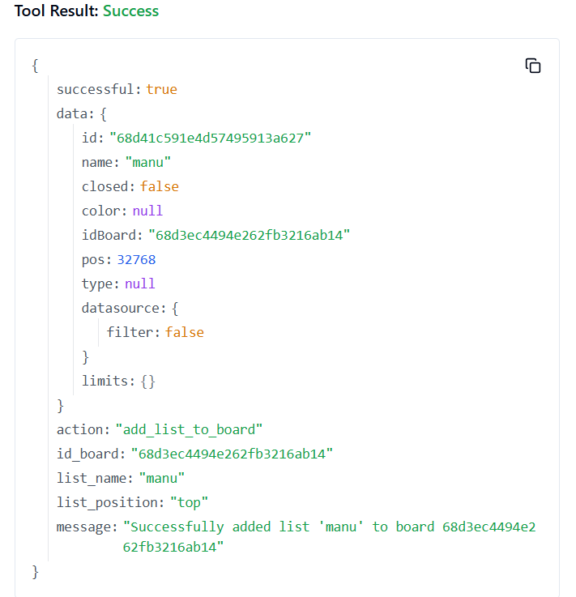

**9. TRELLO_ADD_BOARDS_MARK_AS_VIEWED_BY_ID_BOARD**

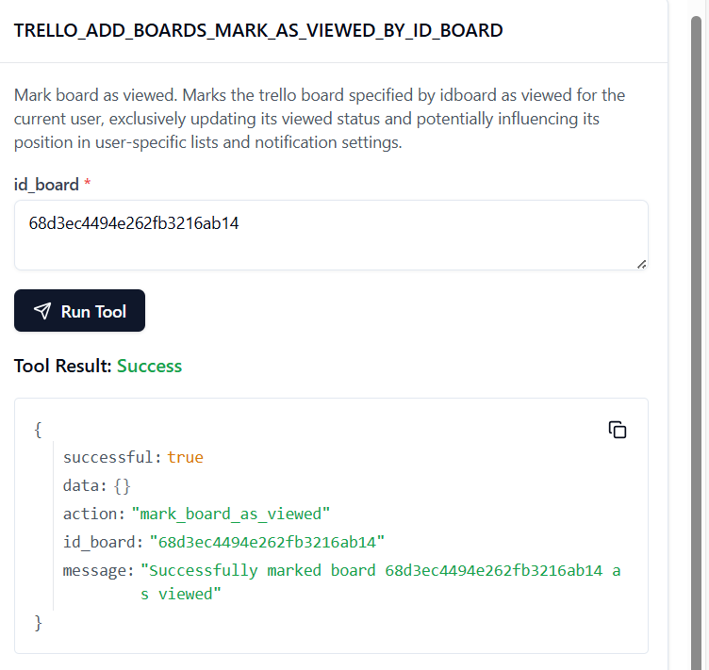

**10. TRELLO_ADD_BOARDS_POWER_UPS_BY_ID_BOARD**

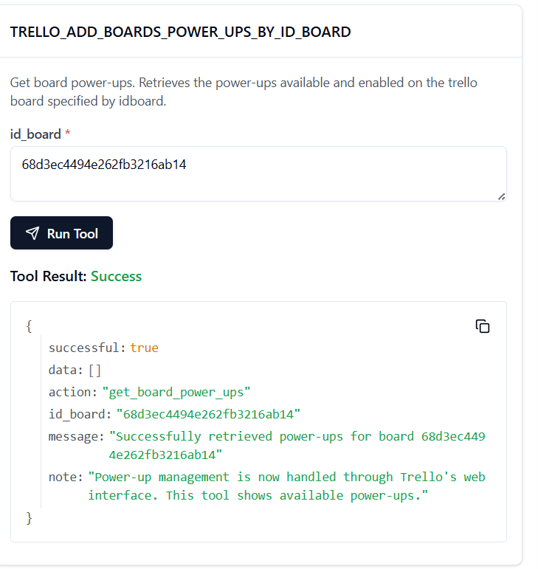

**11. TRELLO_ADD_CARDS**

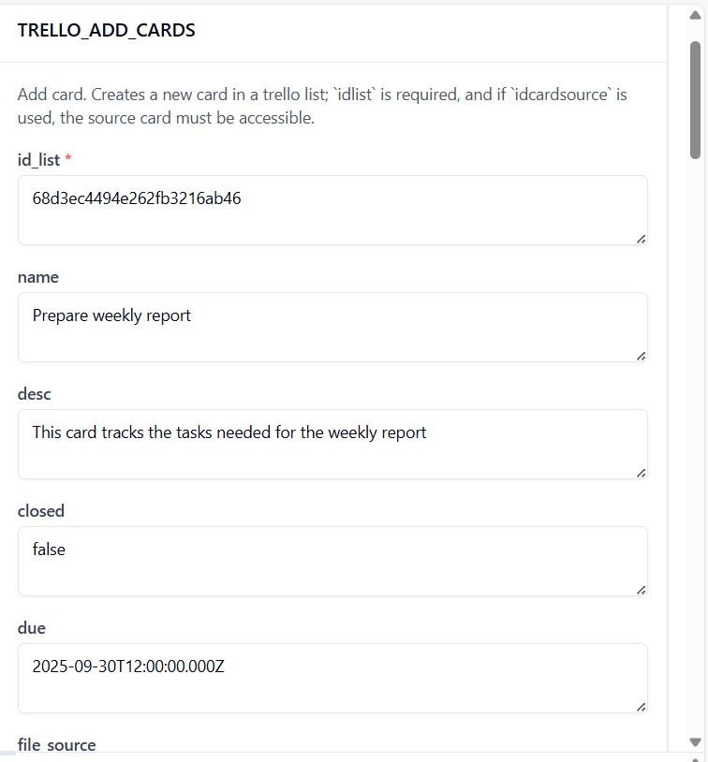

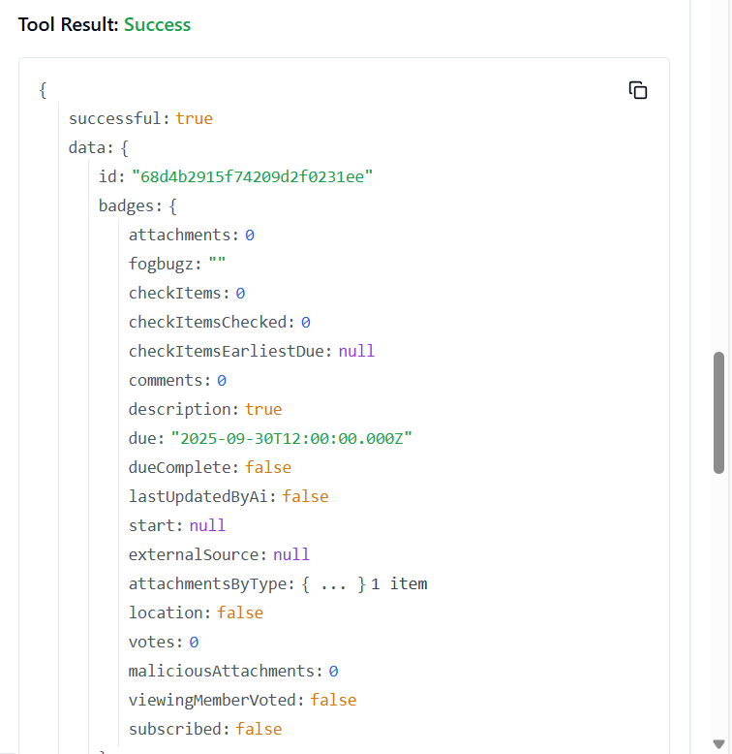

12. **TRELLO_GET_BOARDS_CARDS_BY_ID_BOARD**

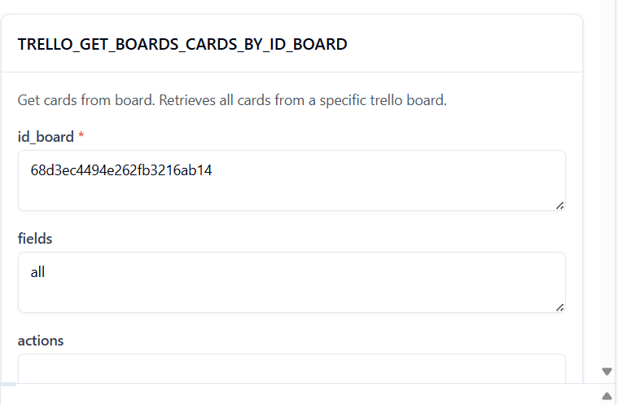

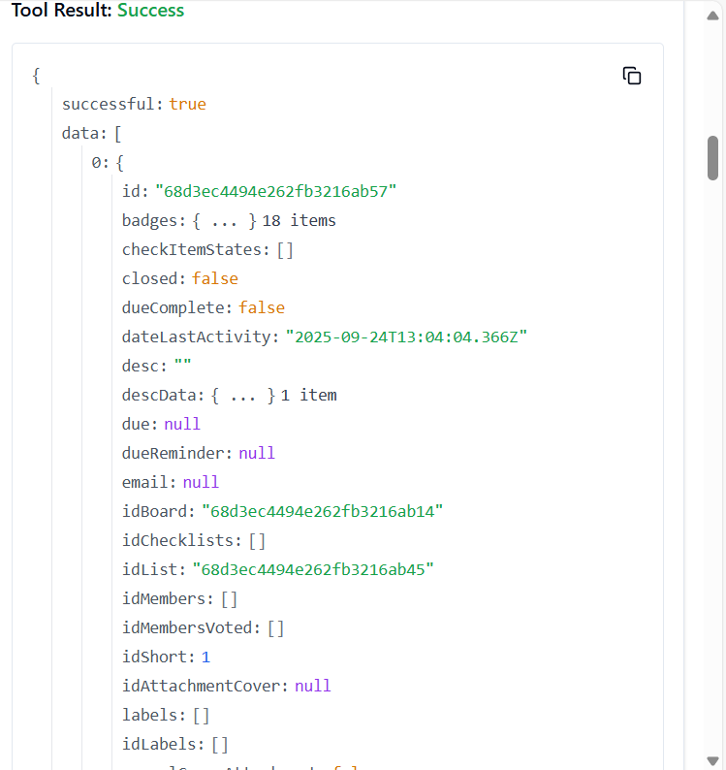

13. **TRELLO_ADD_CARDS_CHECKLISTS_BY_ID_CARD**

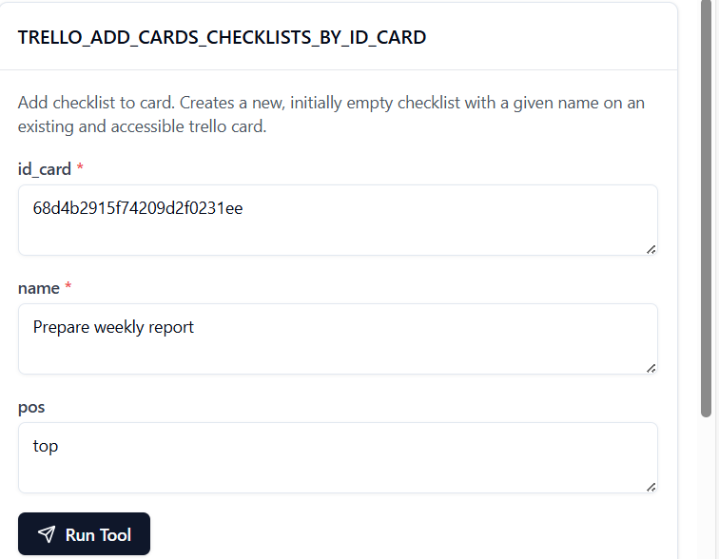

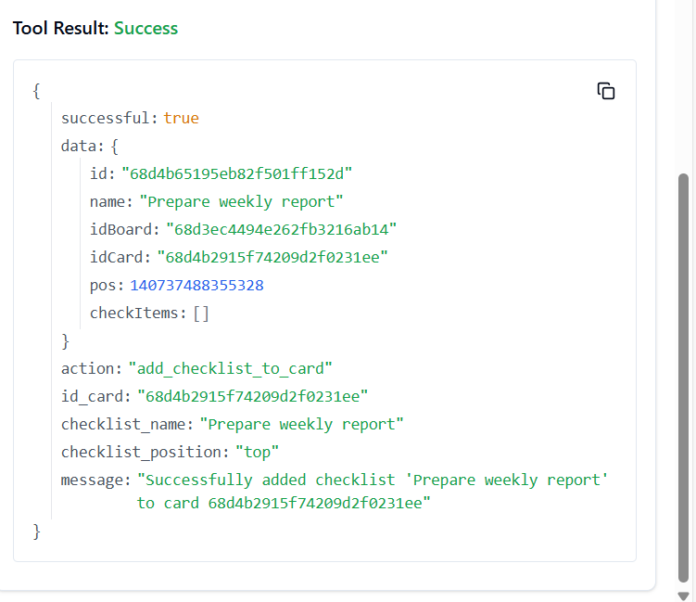

14. **TRELLO_ADD_CARDS_ACTIONS_COMMENTS_BY_ID_CARD**

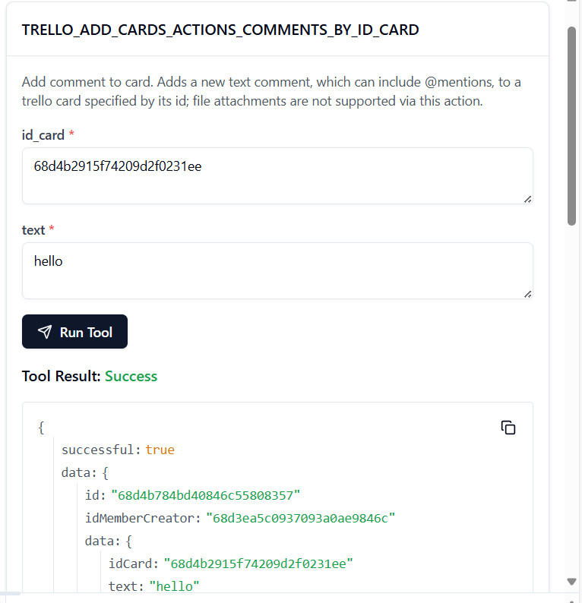

15. **TRELLO_ADD_CARDS_CHECKLIST_CHECK_ITEM_BY_ID_CARD_BY_ID_CHECKLIST**

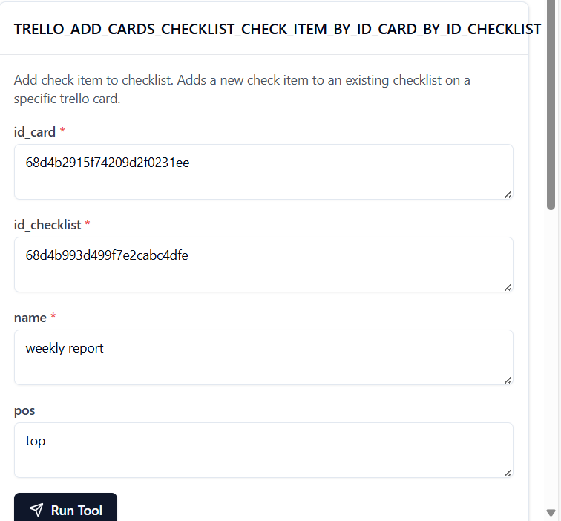

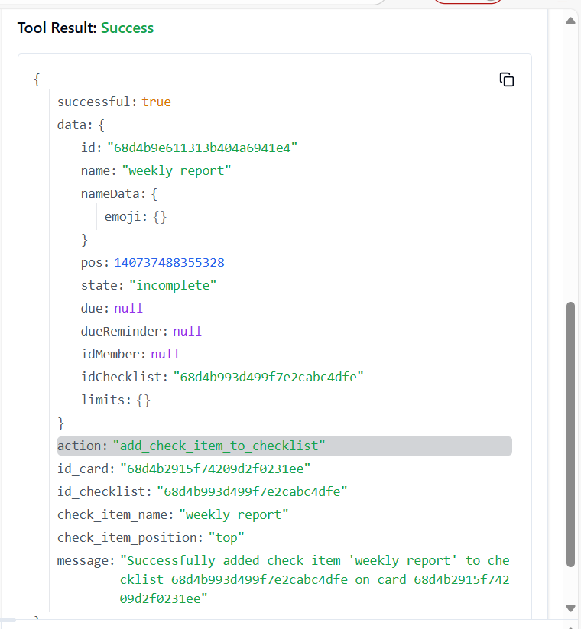

16. **TRELLO_ADD_CARDS_ID_LABELS_BY_ID_CARD**

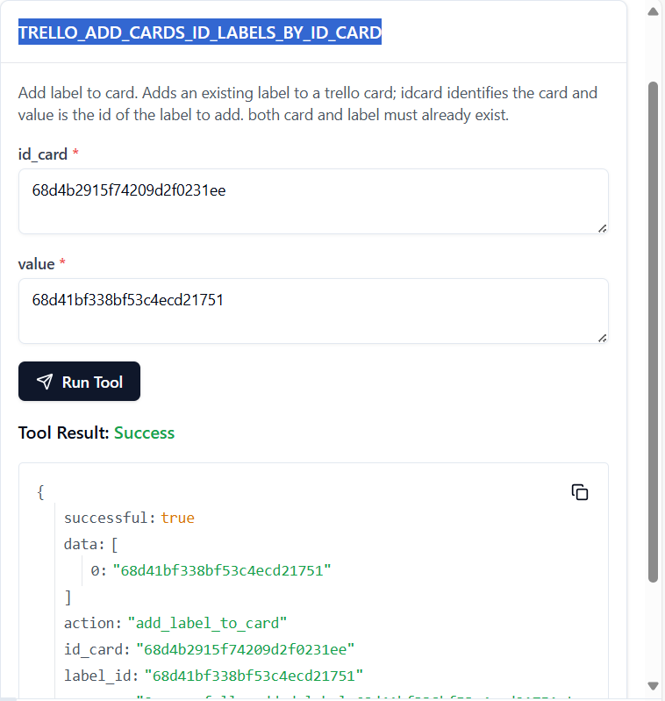

TO GET LABLE: curl -X GET "https://api.trello.com/1/boards/68d3ec4494e262fb3216ab14/labels?key=0e25f87141aa66e3d5d9116f606c989d&token=ATTA65c191642e05fdfd6583611281180e46fcf76d9a504d4f5dc84bcdc175823b26A1261C34"

17. **TRELLO_ADD_CARDS_ID_MEMBERS_BY_ID_CARD**

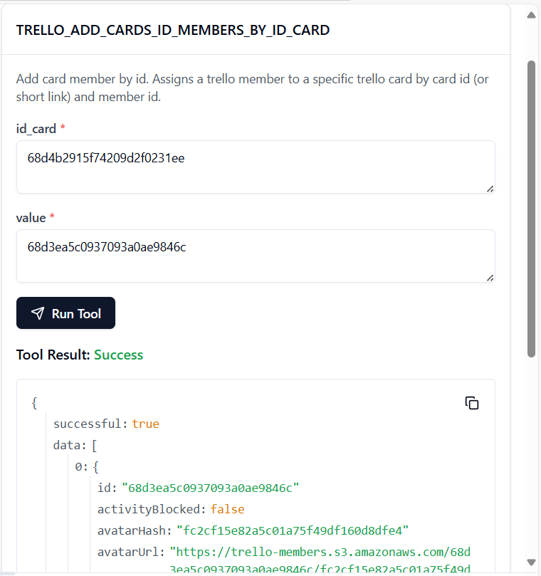

TO GET THE MEMBER ID: curl -X GET <https://api.trello.com/1/boards/68d3ec4494e262fb3216ab14/members?key=0e25f87141aa66e3d5d9116f606c989d&token=ATTA65c191642e05fdfd6583611281180e46fcf76d9a504d4f5dc84bcdc175823b26A1261C34>

18. **TRELLO_ADD_CARDS_LABELS_BY_ID_CARD**

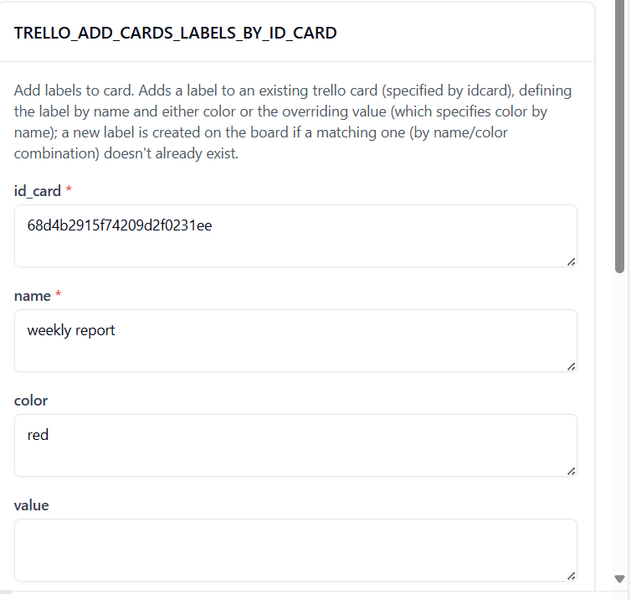

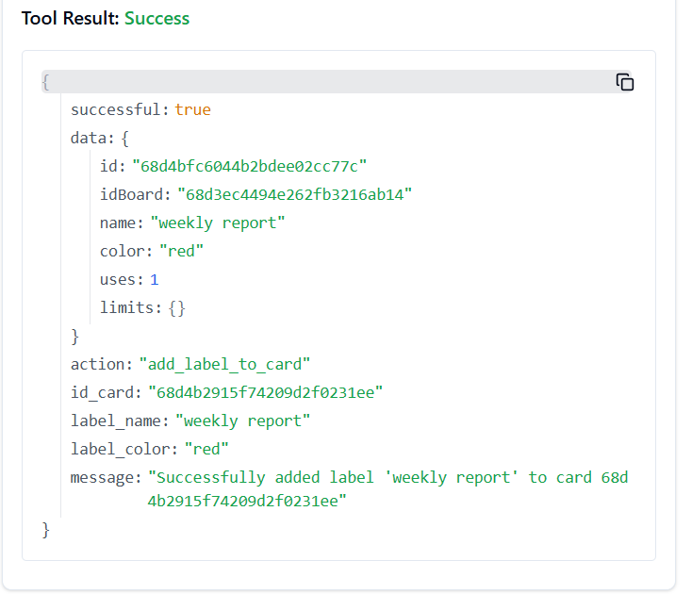

19. **TRELLO_ADD_CARDS_STICKERS_BY_ID_CARD**

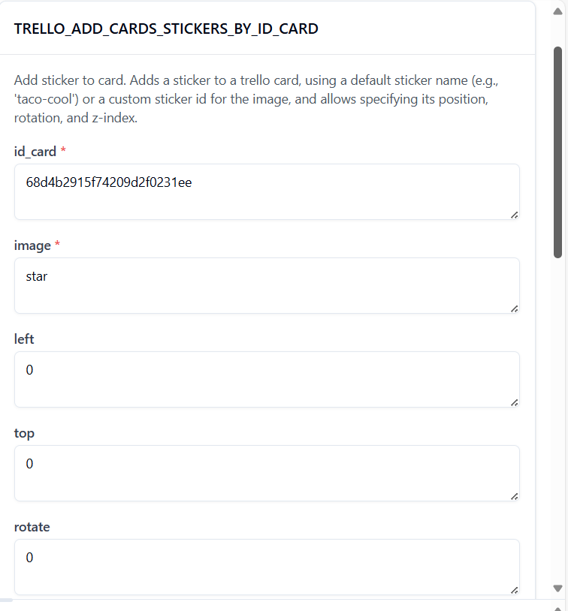

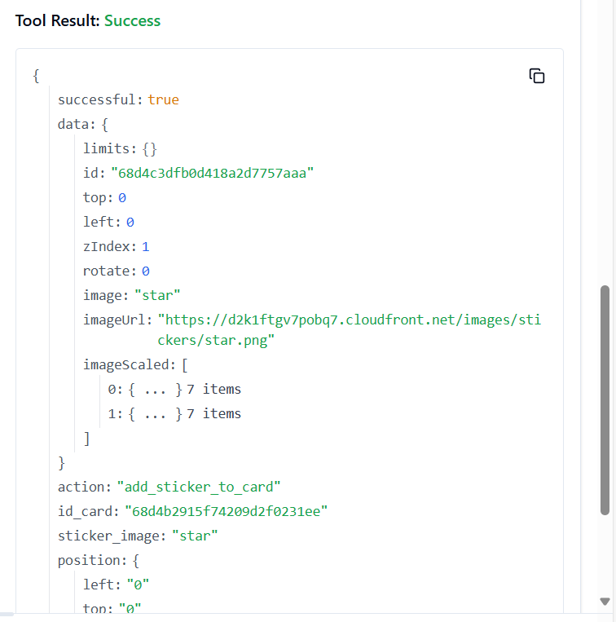

20. **TRELLO_ADD_CHECKLISTS**

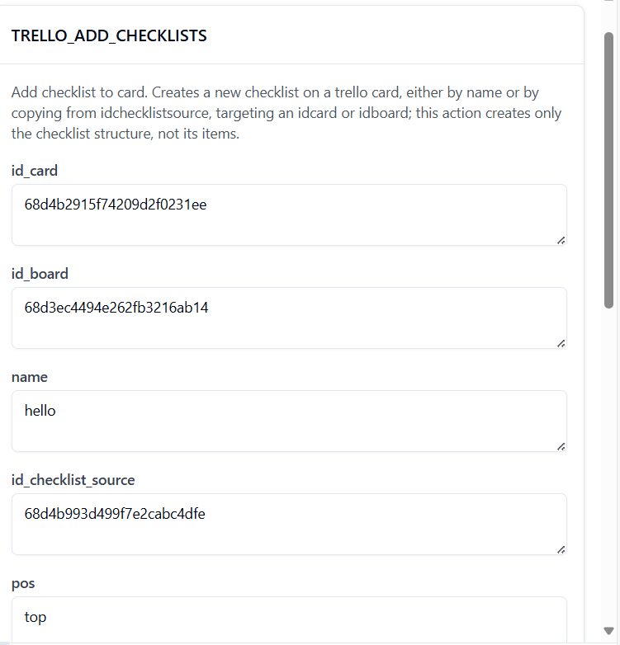

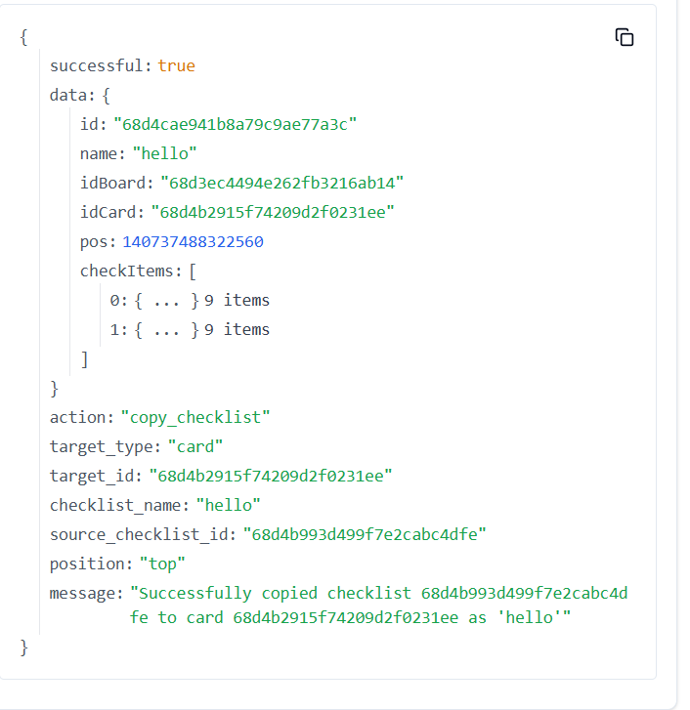

21. **TRELLO_ADD_CHECKLISTS_CHECK_ITEMS_BY_ID_CHECKLIST**

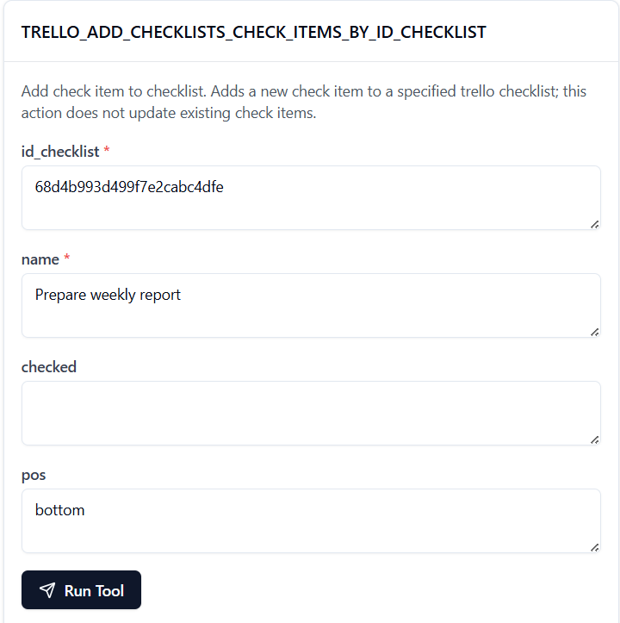

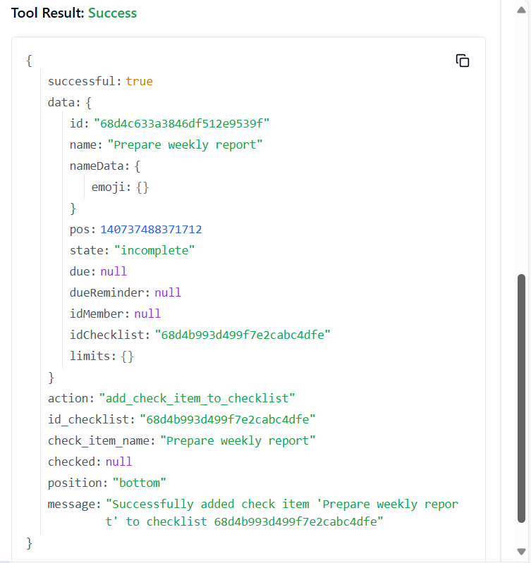

22. **TRELLO_ADD_LABELS**

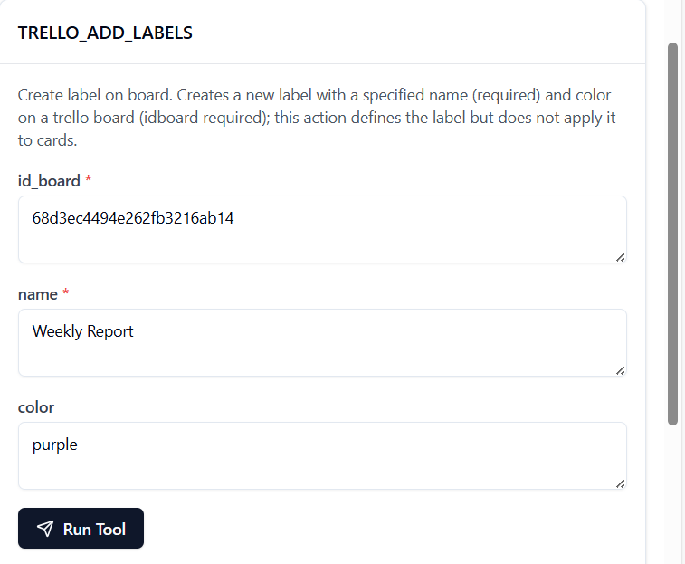

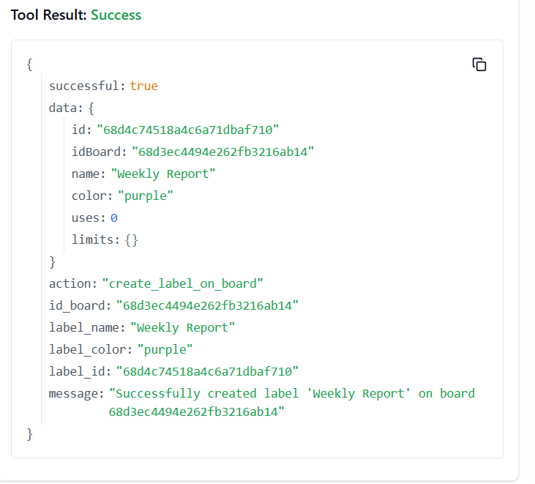

23. **TRELLO_ADD_LISTS**

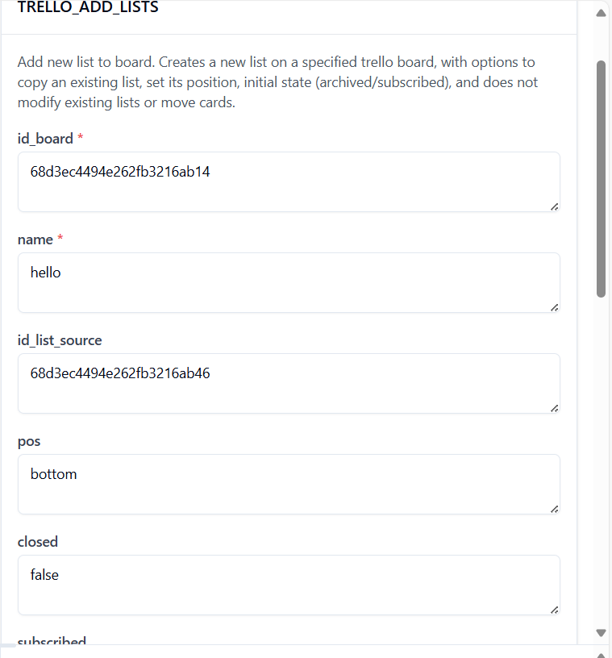

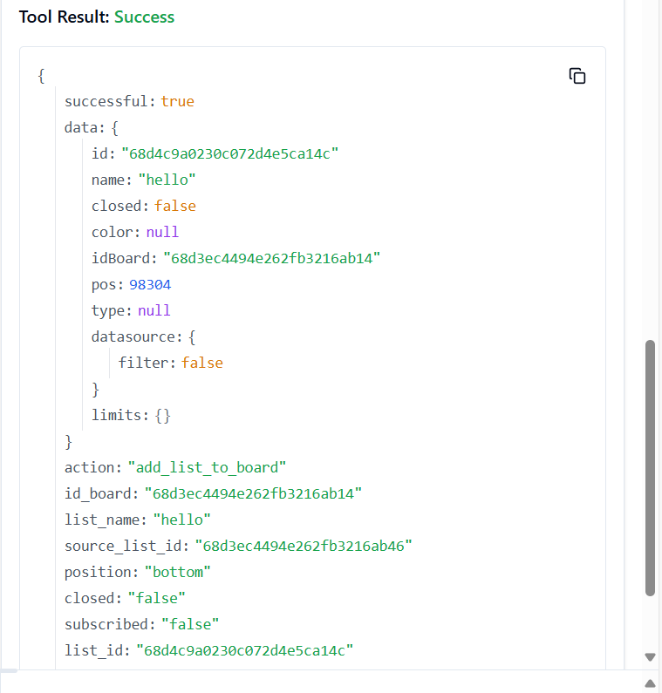

24. **TRELLO_ADD_LISTS_ARCHIVE_ALL_CARDS_BY_ID_LIST**

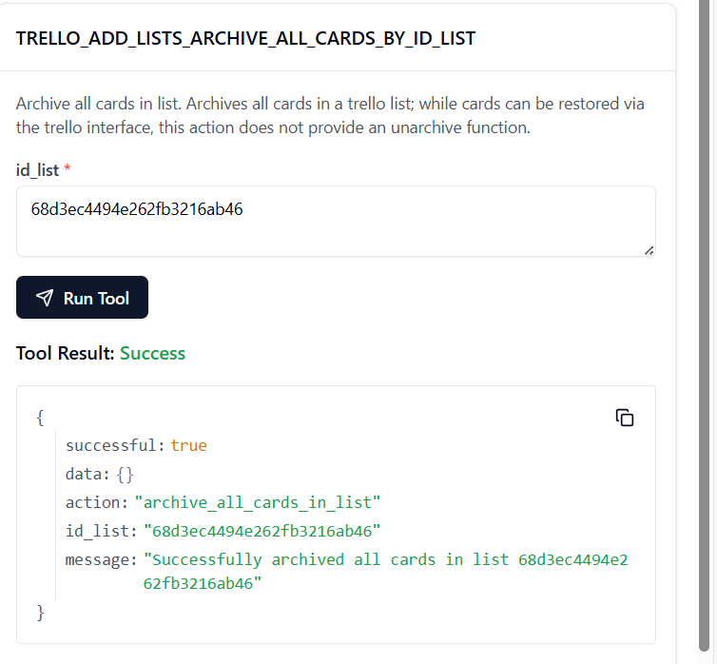

25. **TRELLO_ADD_LISTS_CARDS_BY_ID_LIST**

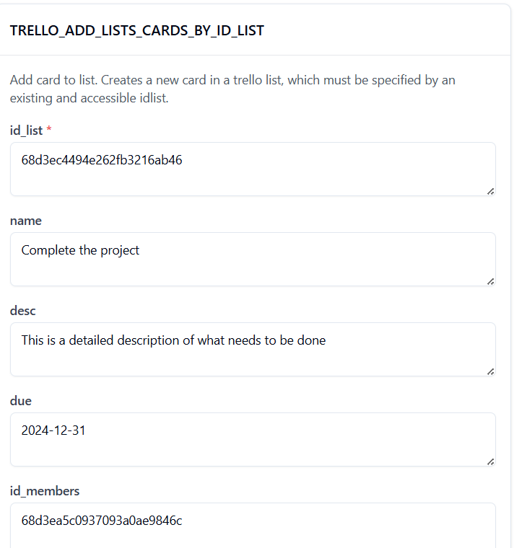

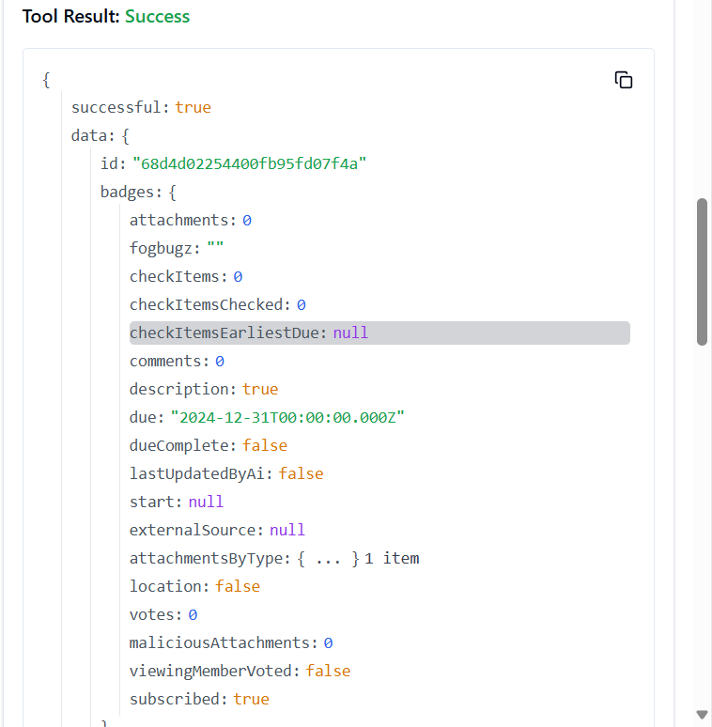

26. **TRELLO_ADD_LISTS_MOVE_ALL_CARDS_BY_ID_LIST**

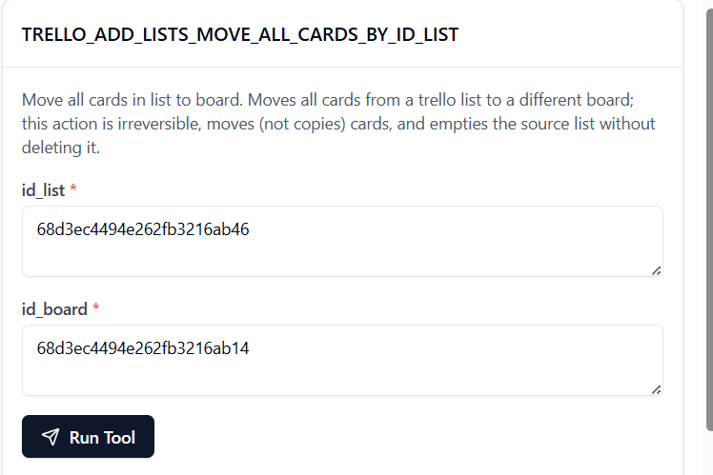

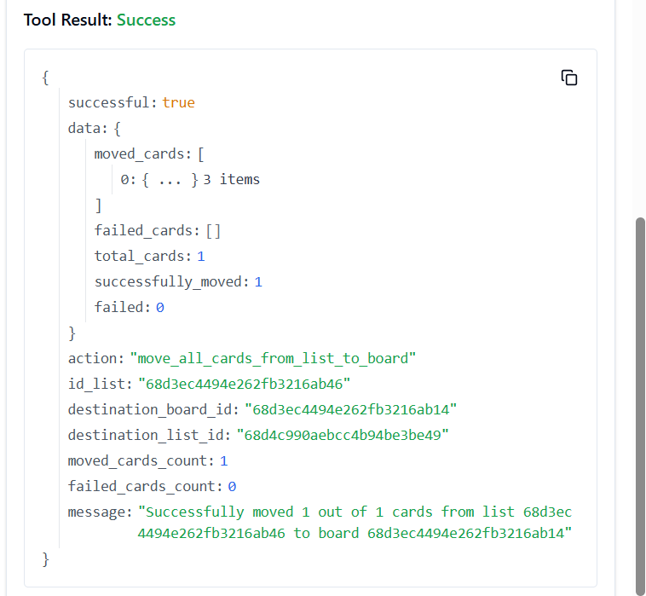

27. **TRELLO_ADD_MEMBERS_BOARD_STARS_BY_ID_MEMBER**

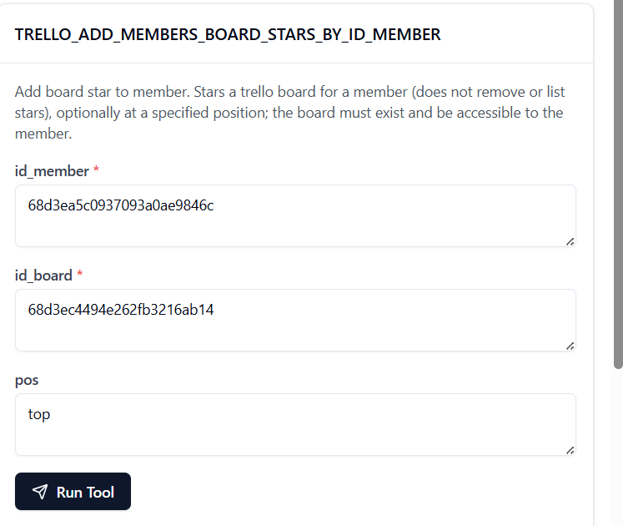

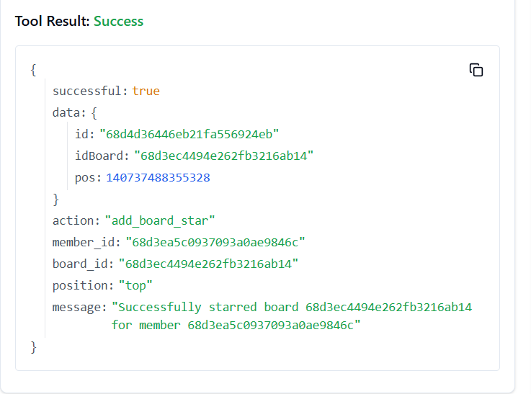

28. **TRELLO_ADD_MEMBERS_SAVED_SEARCHES_BY_ID_MEMBER**

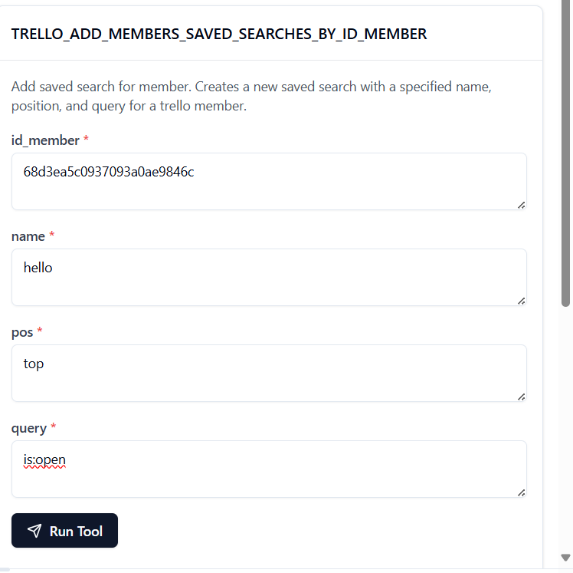

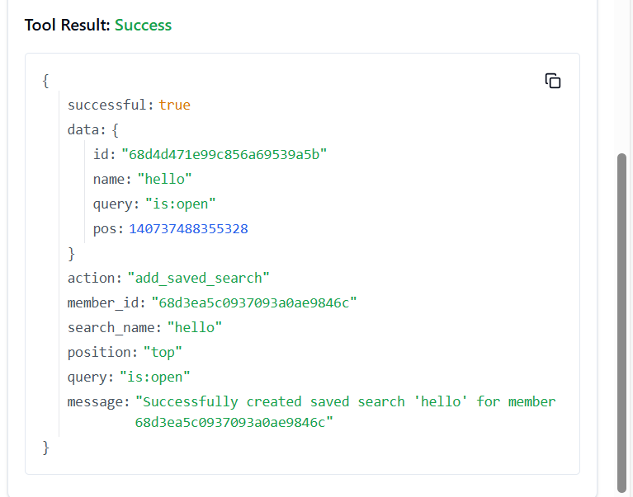

29. **TRELLO_ADD_NOTIFICATIONS_ALL_READ**

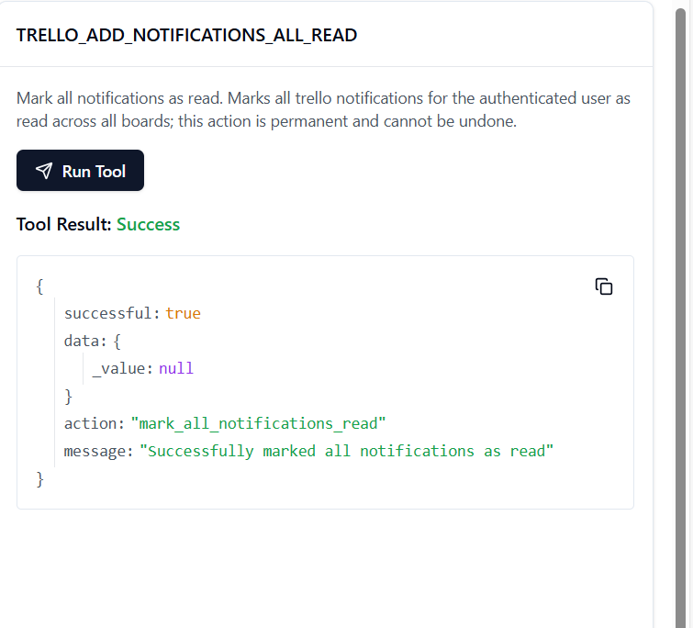30. **TRELLO_ADD_ORGANIZATIONS**

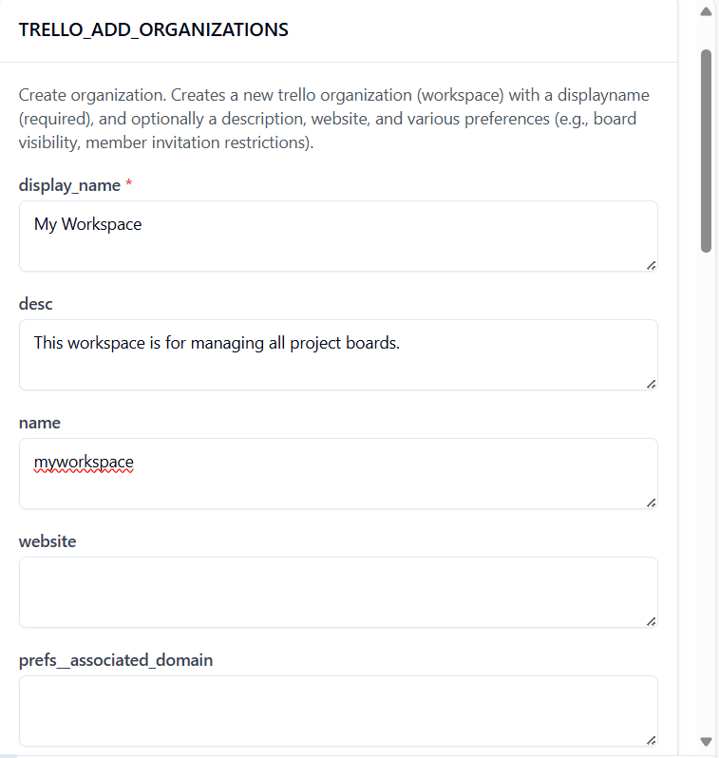

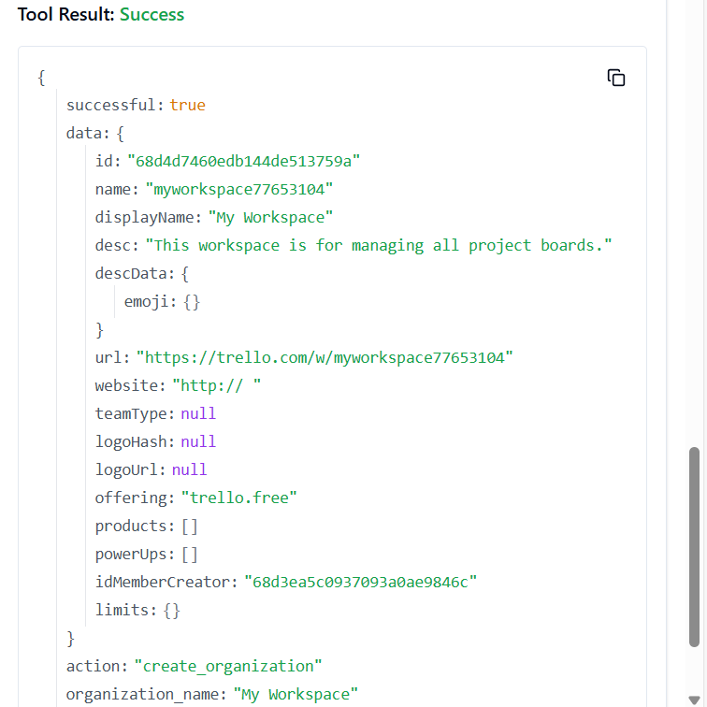

31. **TRELLO_BOARD_CREATE_BOARD**

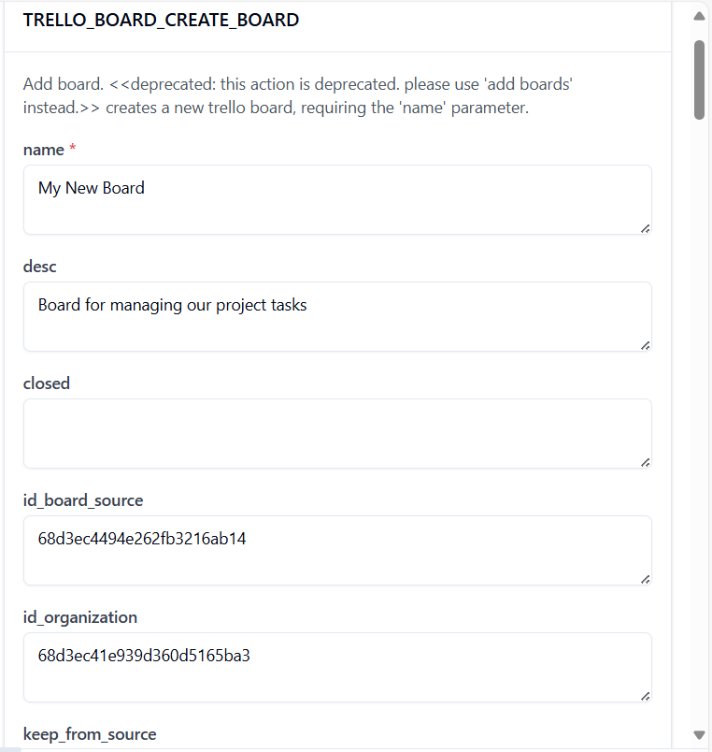

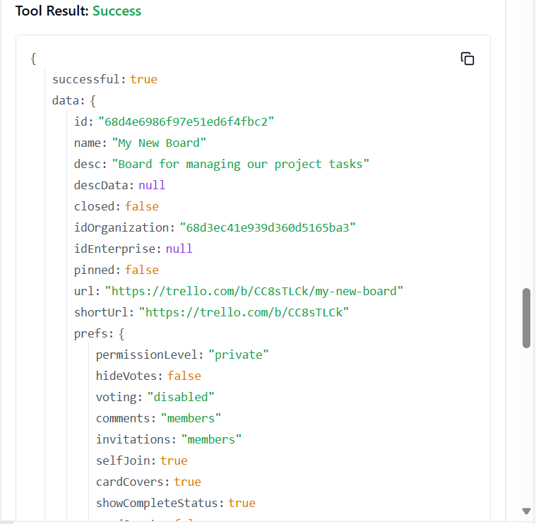

32. **TRELLO_BOARD_FILTER_CARDS_BY_ID_BOARD**

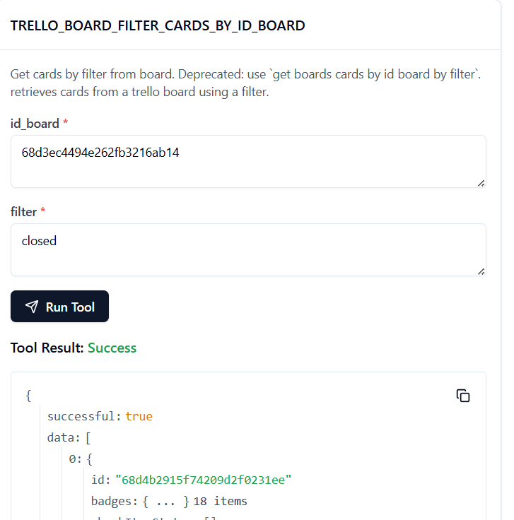

33. **TRELLO_BOARD_GET_LISTS_BY_ID_BOARD**

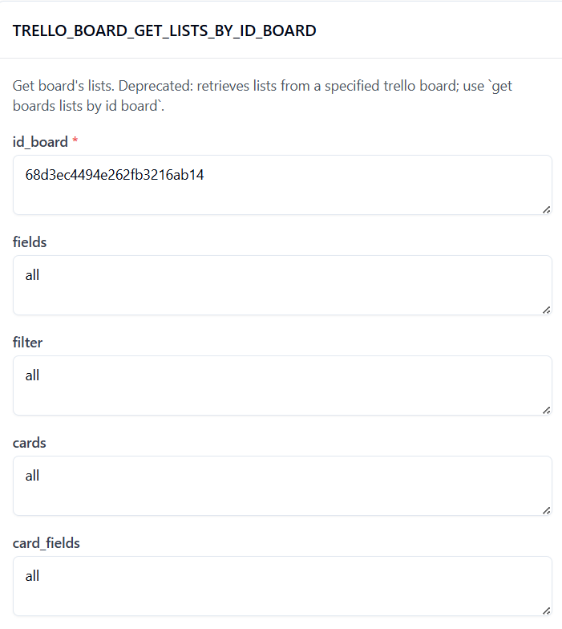

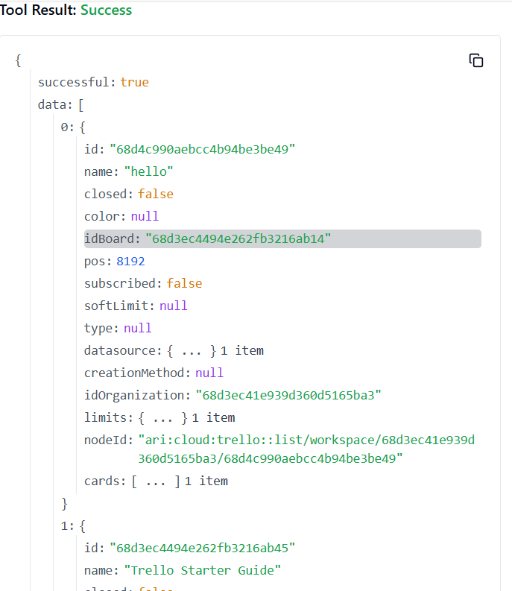

34. **TRELLO_CARD_GET_BY_ID_FIELD**

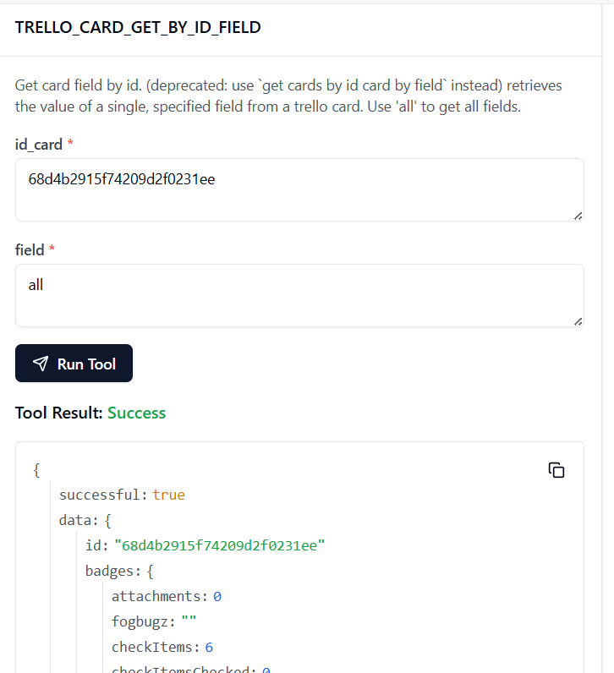

35. **TRELLO_CARD_UPDATE_ID_LIST_BY_ID_CARD**

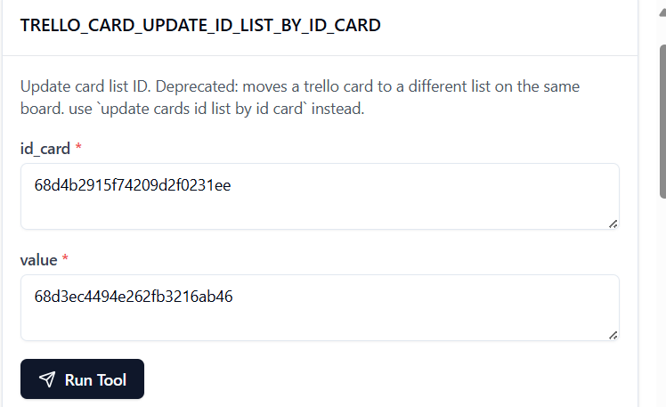

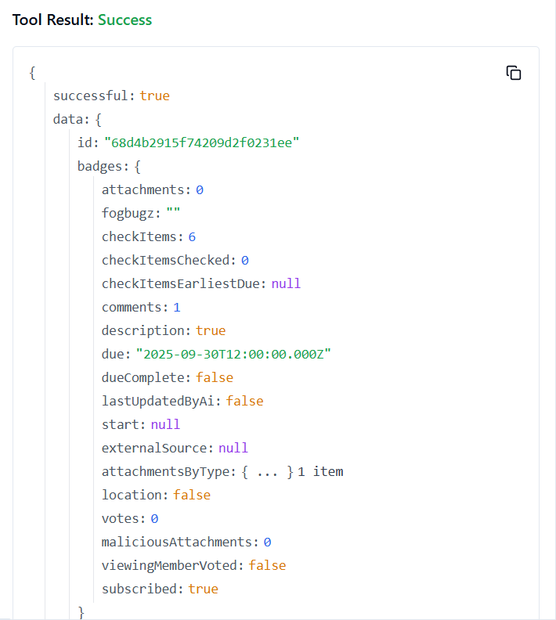

36. **TRELLO_CARD_UPDATE_POS_BY_ID_CARD**

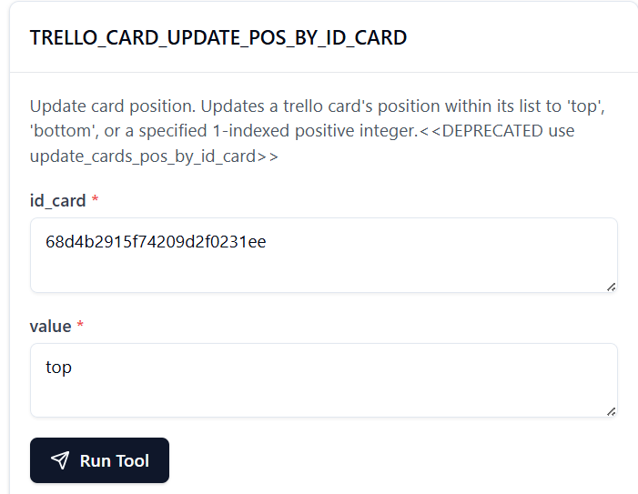

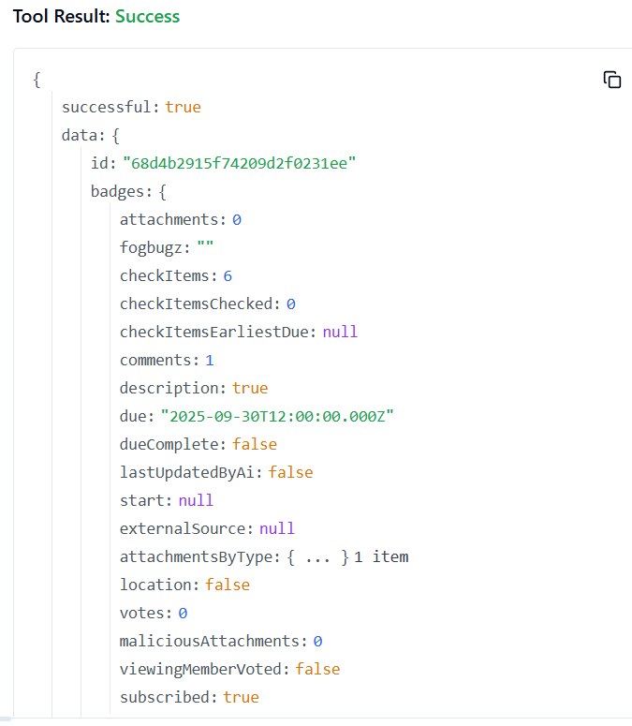

37. **TRELLO_CONVERT_CHECKLIST_ITEM_TO_CARD**

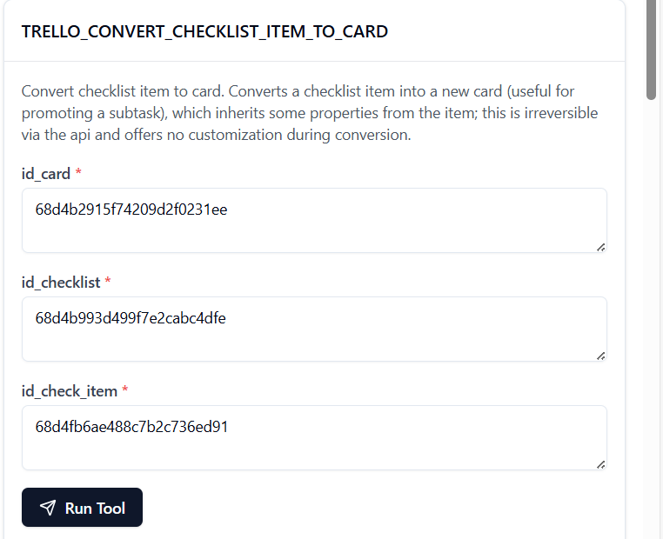

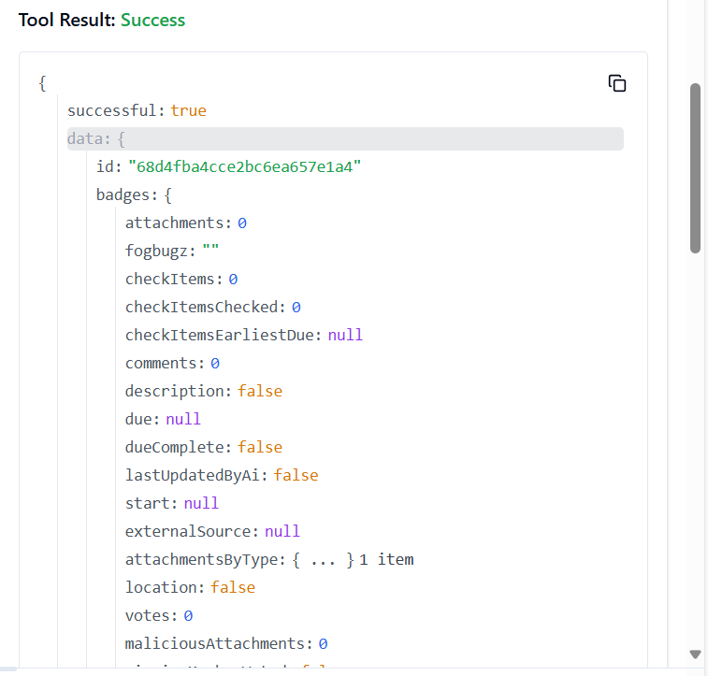

38. **TRELLO_GET_ACTIONS_BOARD_BY_ID_ACTION**

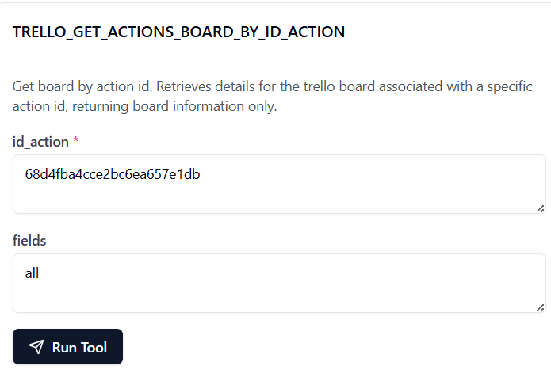

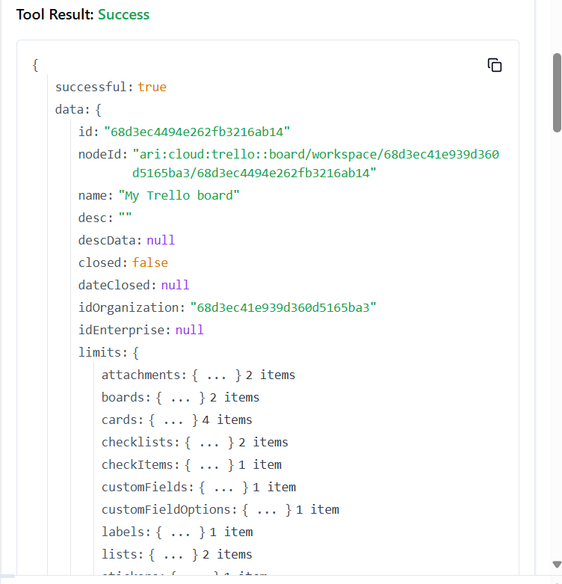

39. **TRELLO_GET_ACTIONS_BOARD_BY_ID_ACTION_BY_FIELD**

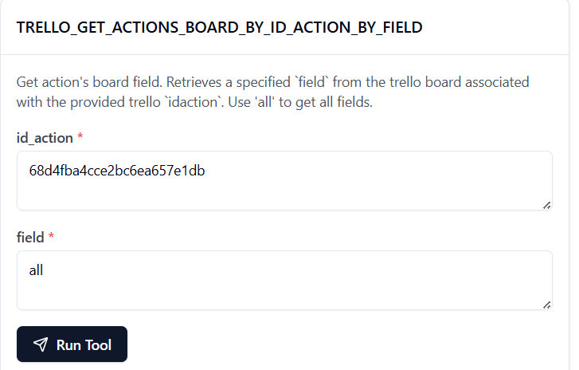

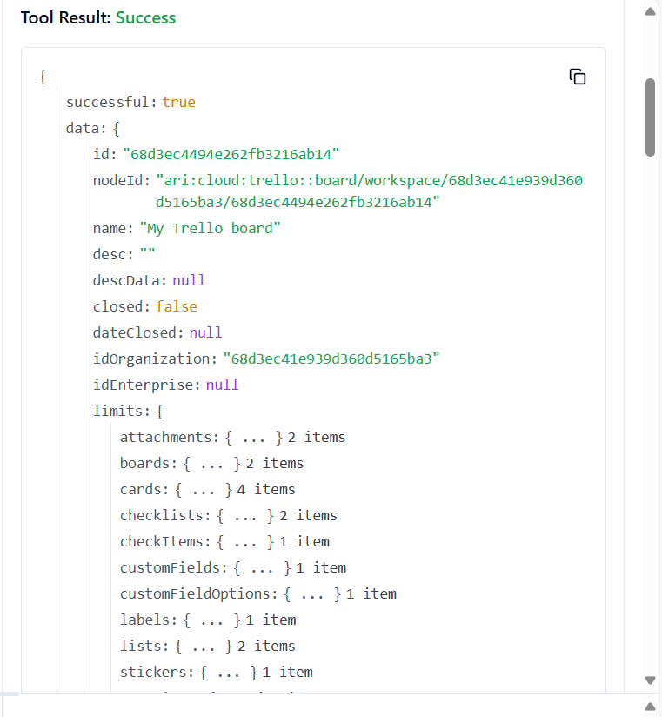

40. **TRELLO_GET_ACTIONS_BY_ID_ACTION**

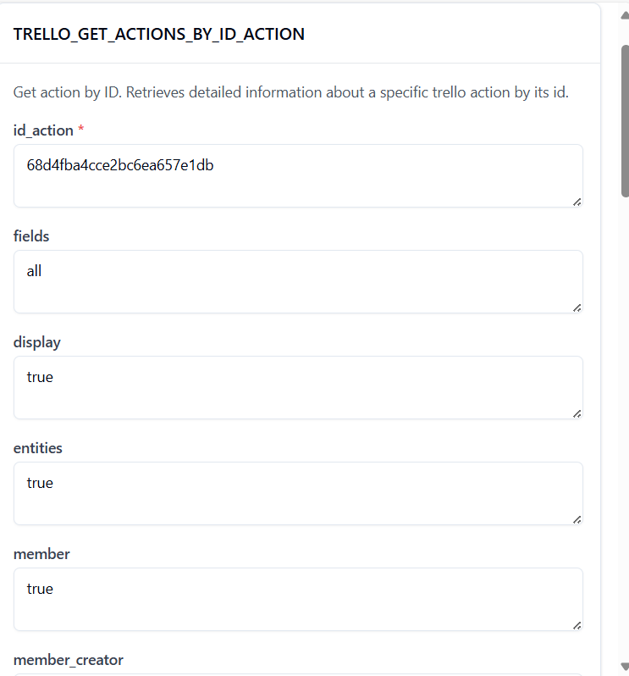

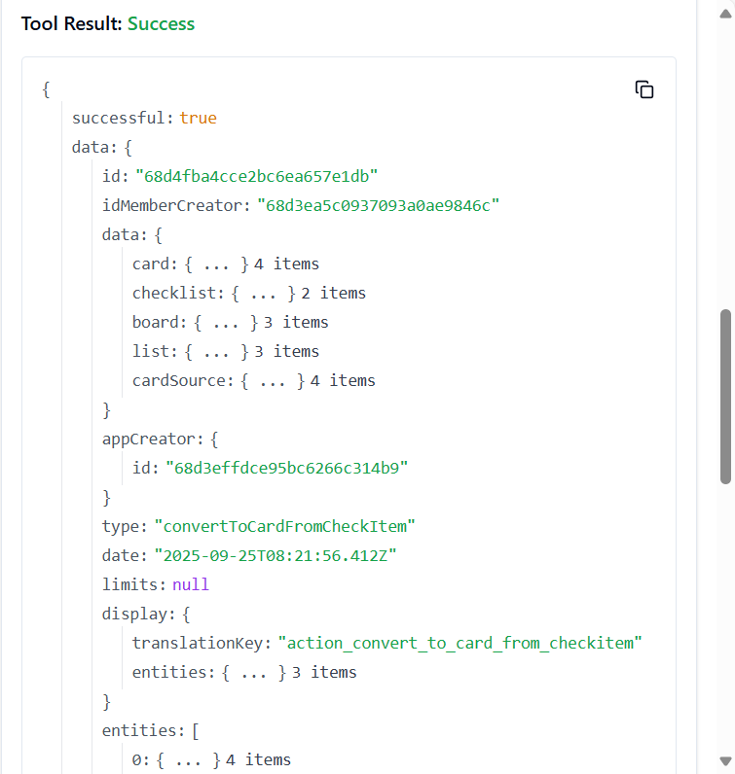

41. **TRELLO_GET_ACTIONS_BY_ID_ACTION_BY_FIELD**

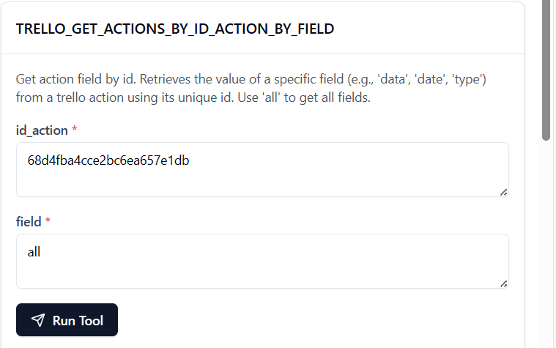

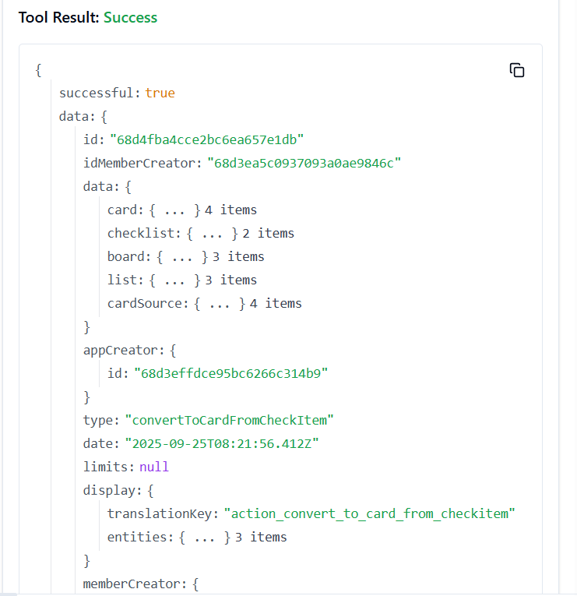

42.**TRELLO_GET_ACTIONS_CARD_BY_ID_ACTION**

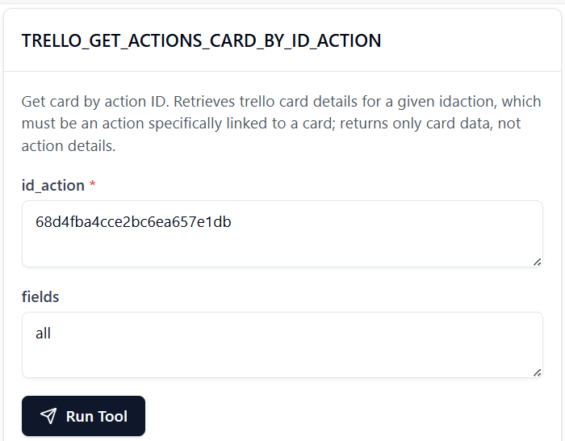

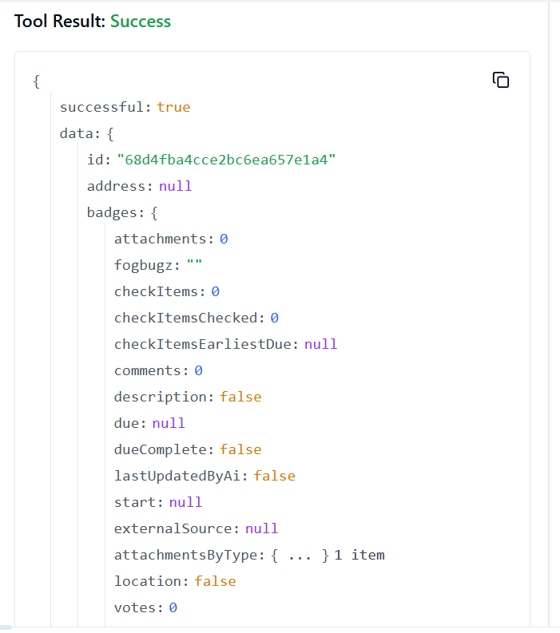

43. **TRELLO_GET_ACTIONS_CARD_BY_ID_ACTION_BY_FIELD**

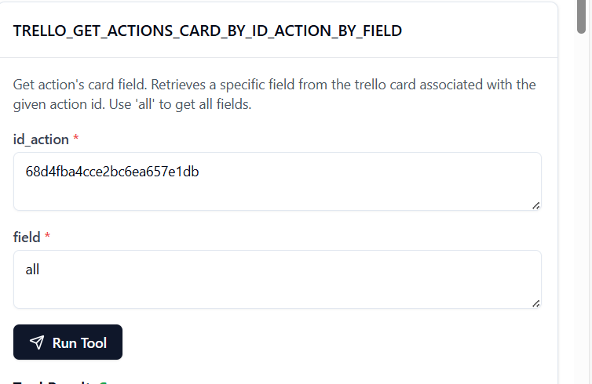

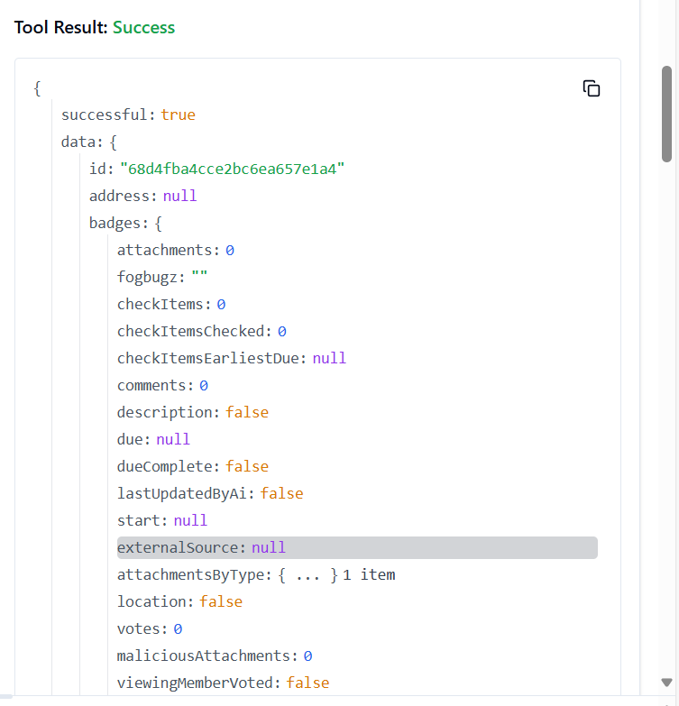

44. **TRELLO_GET_ACTIONS_DISPLAY_BY_ID_ACTION**

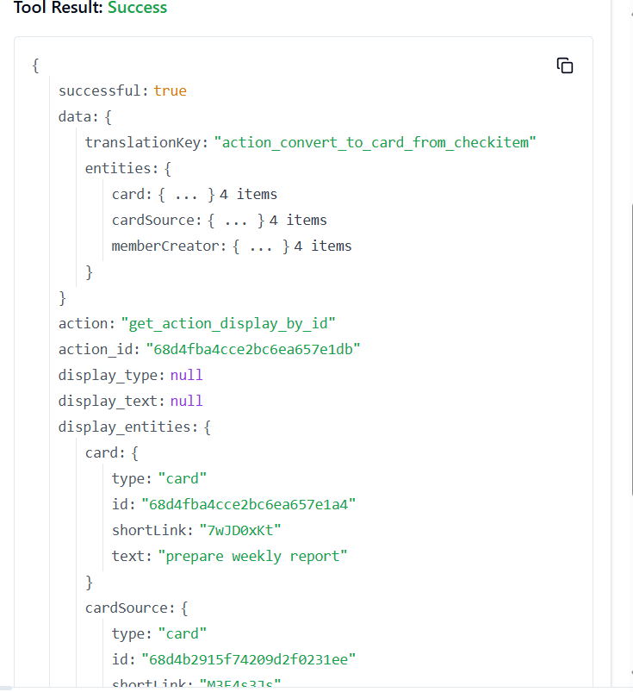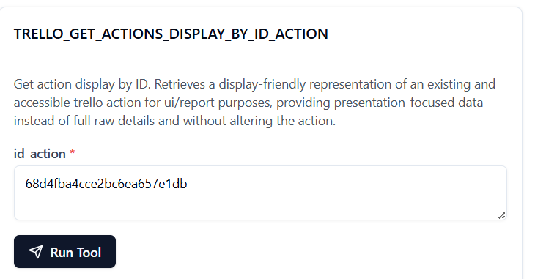

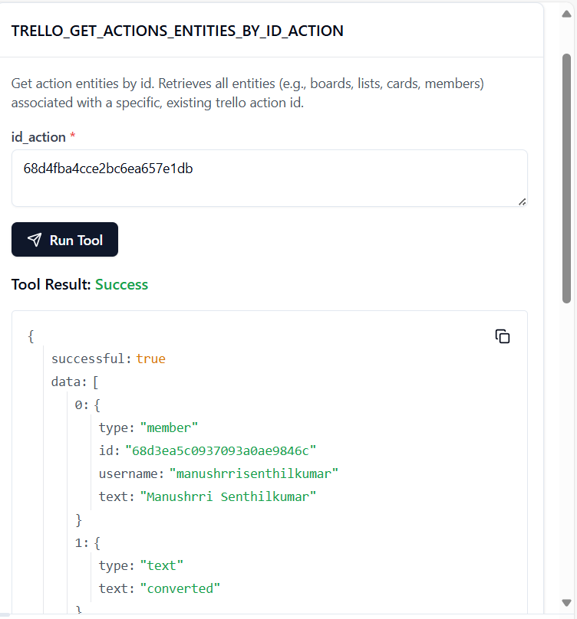45. **TRELLO_GET_ACTIONS_ENTITIES_BY_ID_ACTION**

46. **TRELLO_GET_ACTIONS_LIST_BY_ID_ACTION**

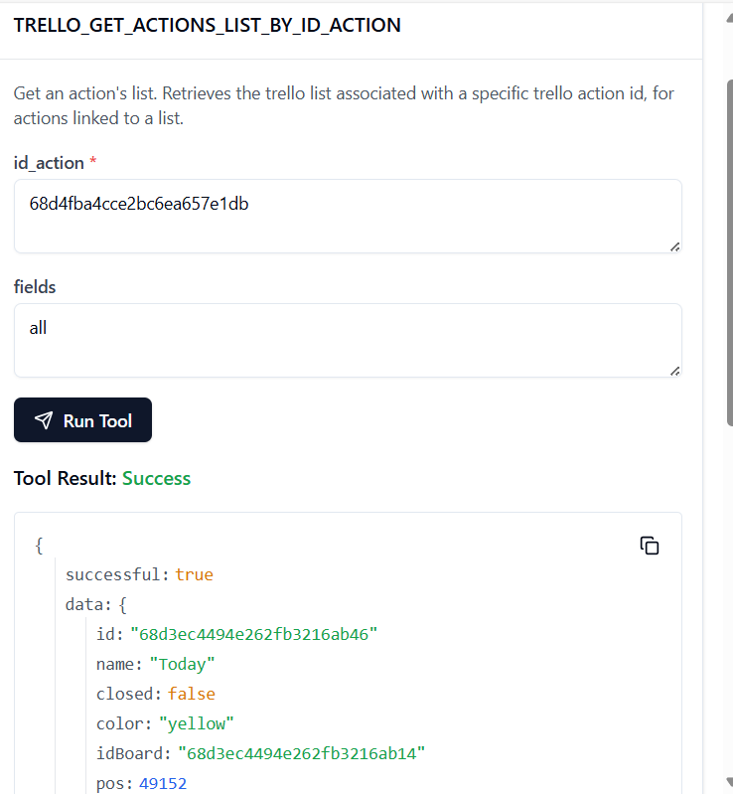

47. **TRELLO_GET_ACTIONS_LIST_BY_ID_ACTION_BY_FIELD**

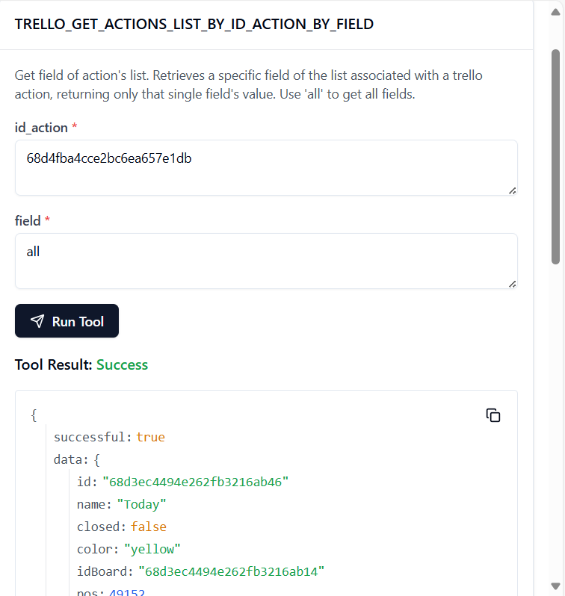

48. **TRELLO_GET_ACTIONS_MEMBER_BY_ID_ACTION**

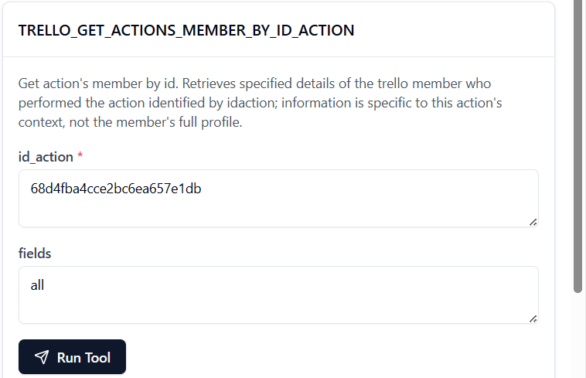

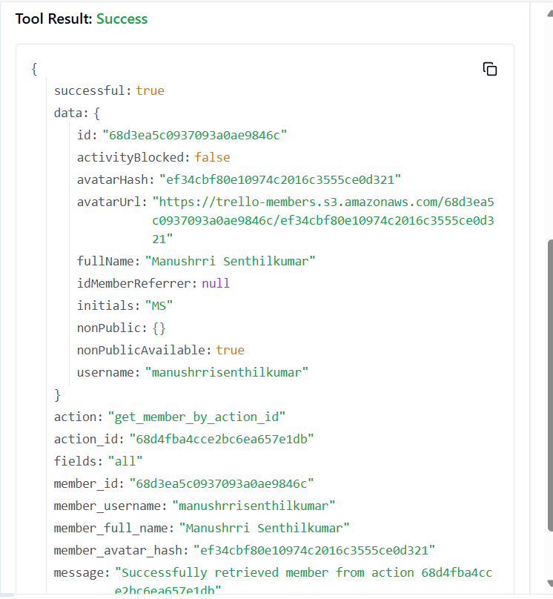

49. **TRELLO_GET_ACTIONS_MEMBER_BY_ID_ACTION_BY_FIELD**

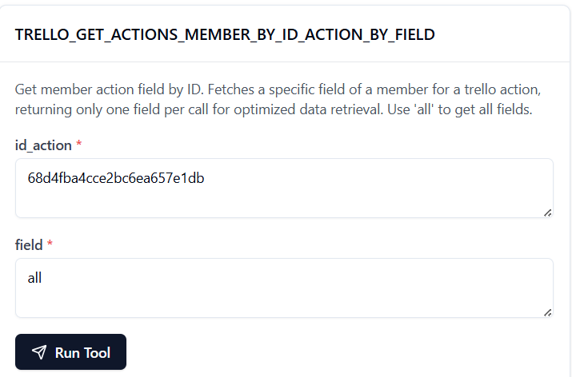

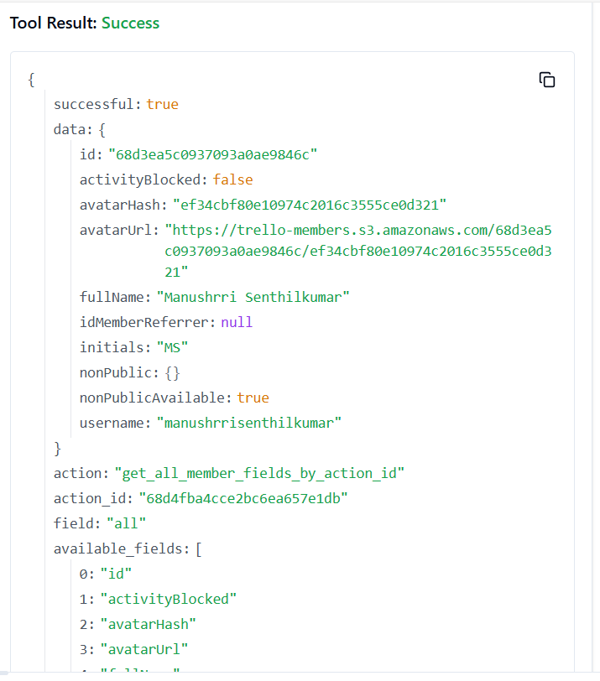

50. **TRELLO_GET_ACTIONS_MEMBER_CREATOR_BY_ID_ACTION**

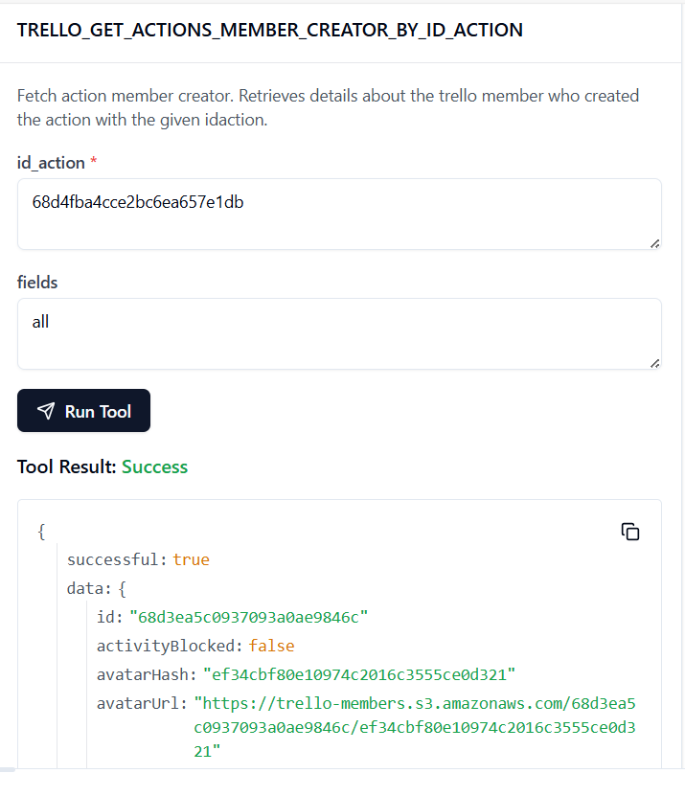

51. **TRELLO_GET_ACTIONS_MEMBER_CREATOR_BY_ID_ACTION_BY_FIELD**

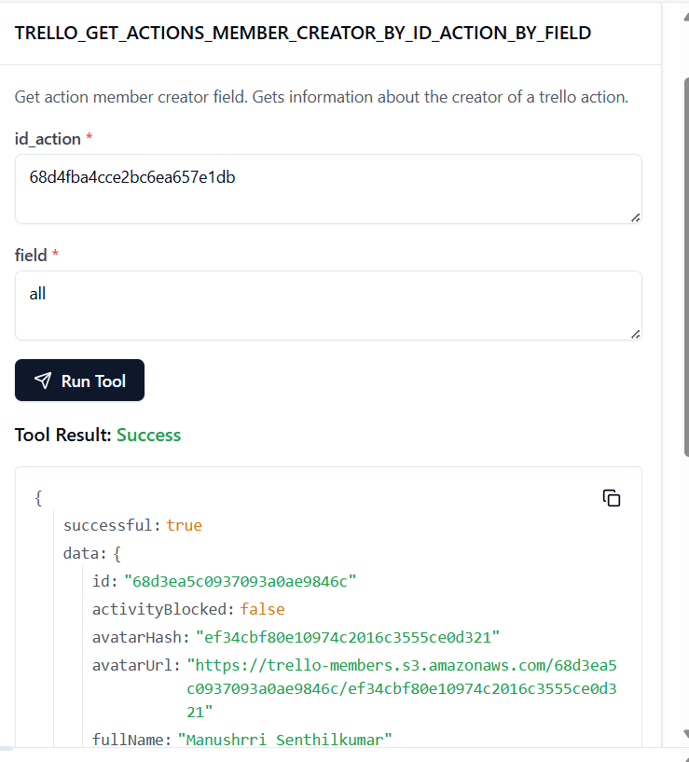

52. TRELLO_GET_ACTIONS_ORGANIZATION_BY_ID_ACTION

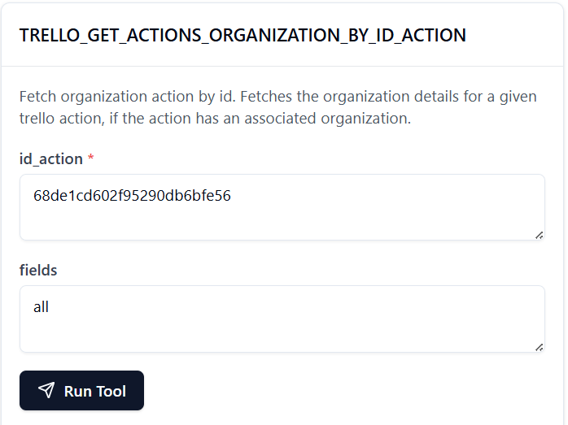

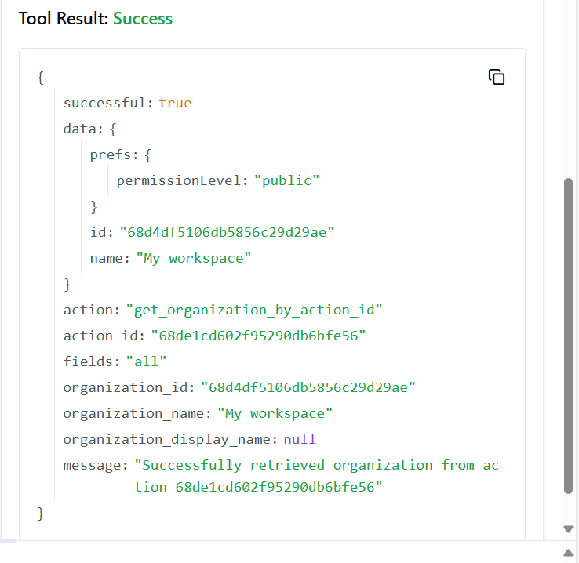

53. TRELLO_GET_ACTIONS_ORGANIZATION_BY_ID_ACTION_BY_FIELD

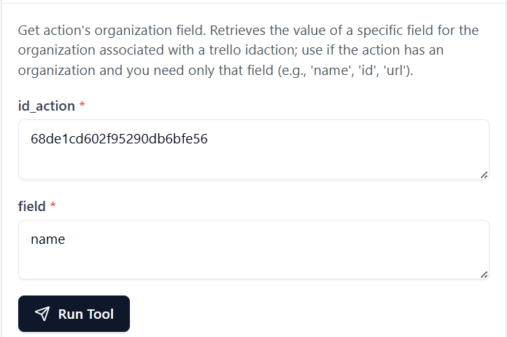

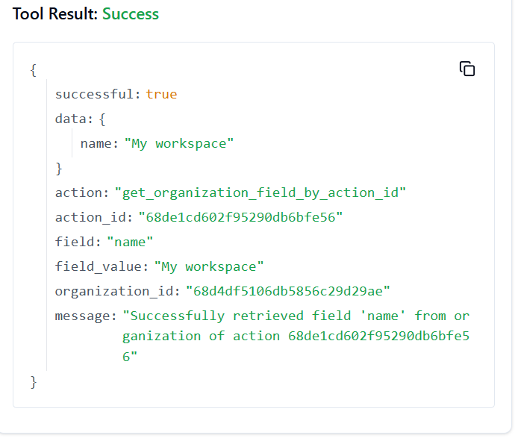

54. **TRELLO_GET_BATCH**

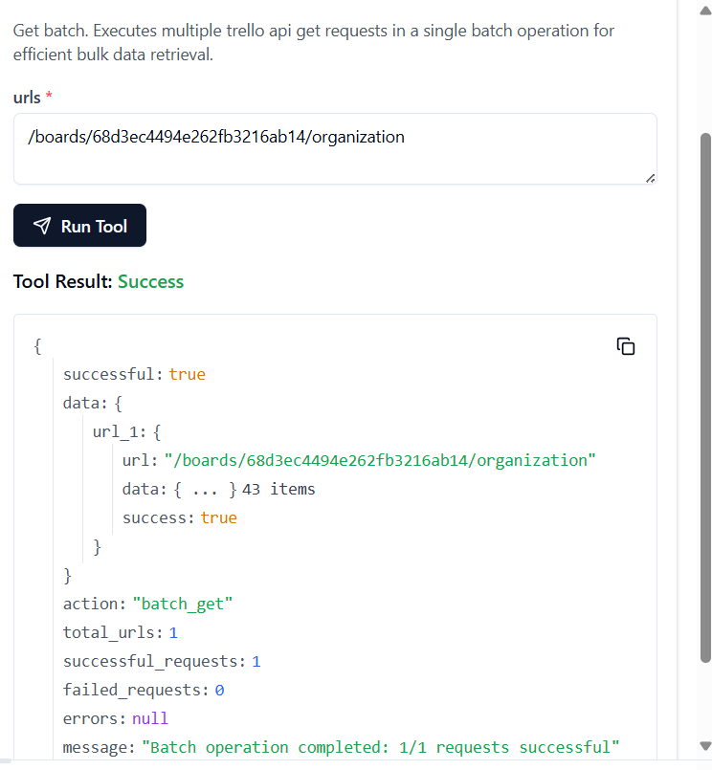

55. **TRELLO_GET_BOARDS_ACTIONS_BY_ID_BOARD**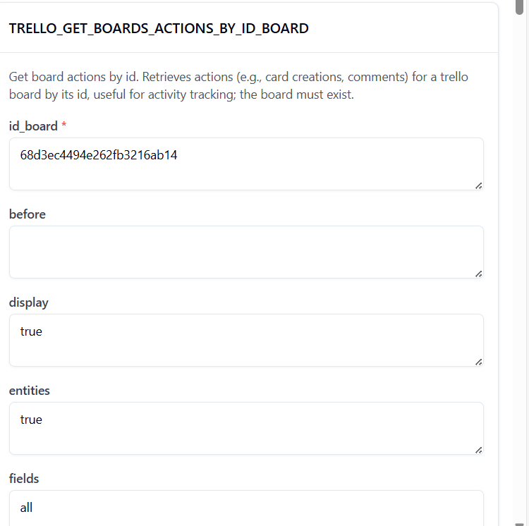

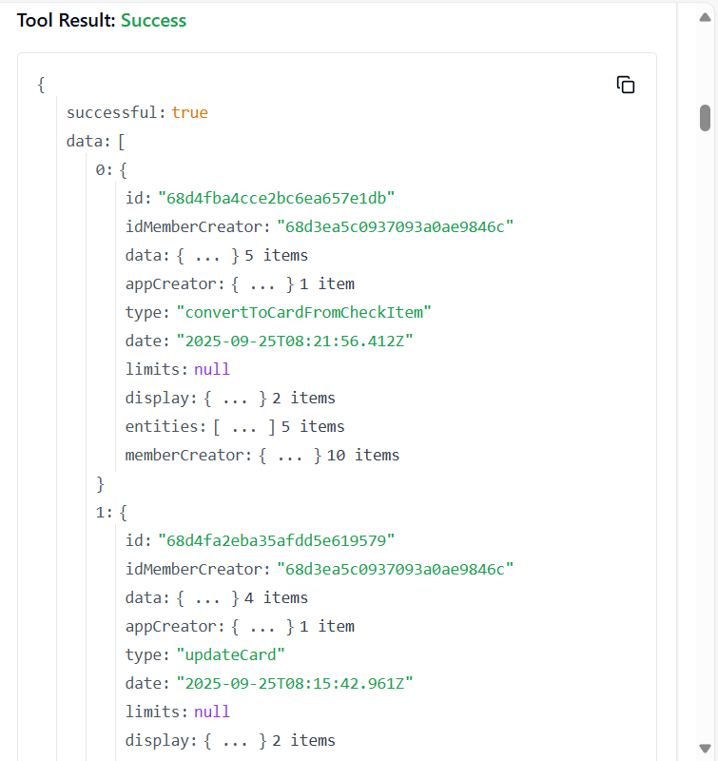

56. **TRELLO_GET_BOARDS_STARS_BY_ID_BOARD**

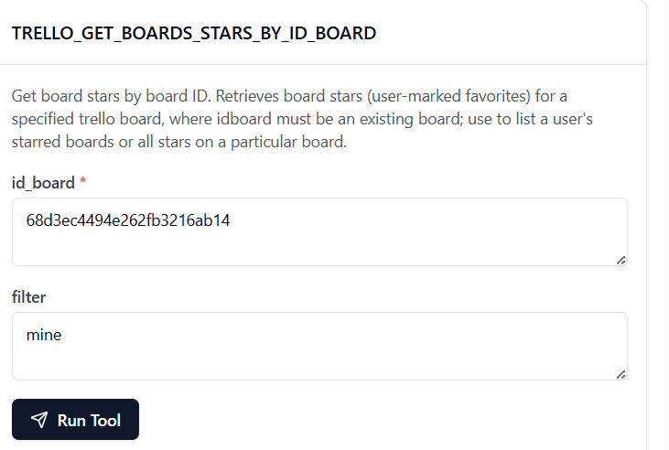

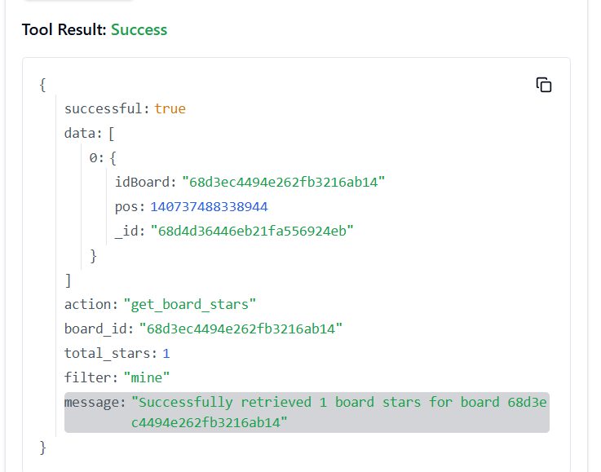

57. **TRELLO_GET_BOARDS_BOARD_STARS_BY_ID_BOARD**

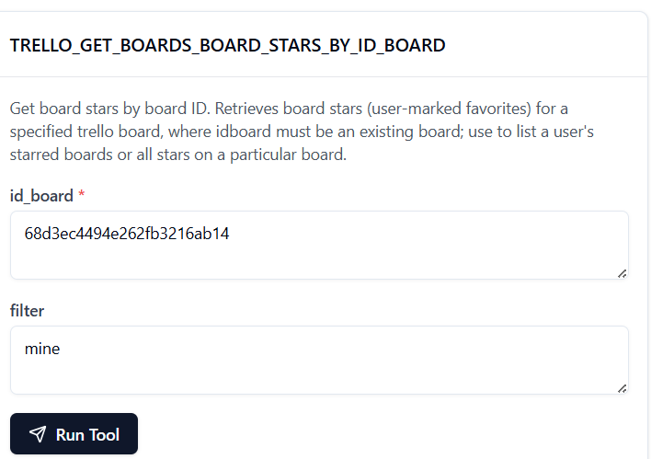

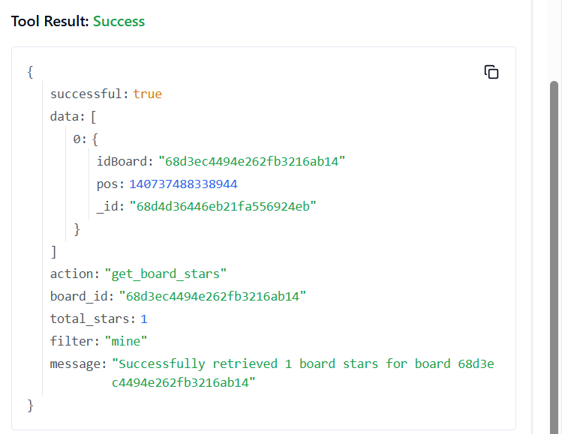

58. **TRELLO_GET_BOARDS_BY_ID_BOARD**

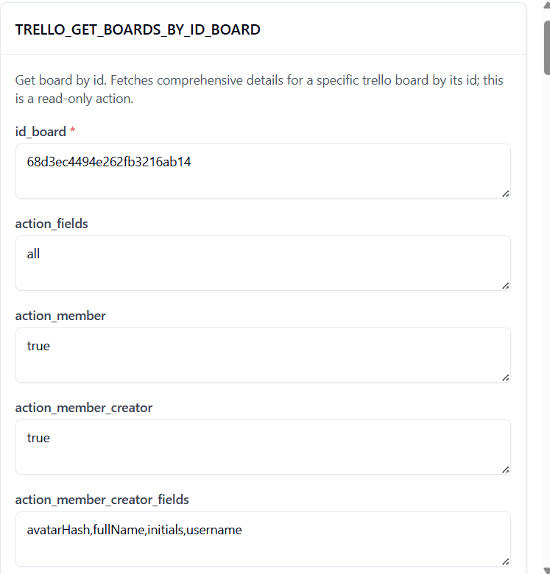

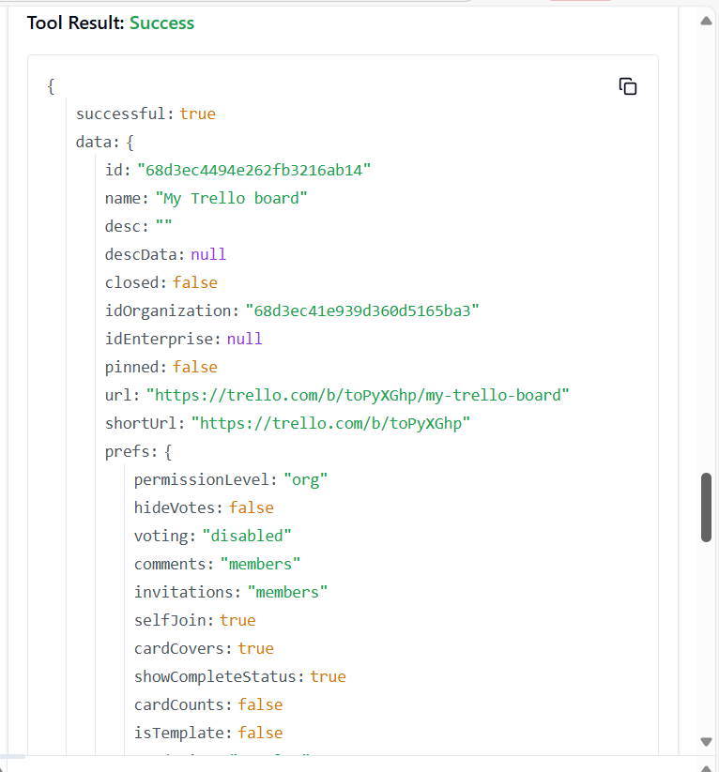

59. **TRELLO_GET_BOARDS_BY_ID_BOARD_BY_FIELD**

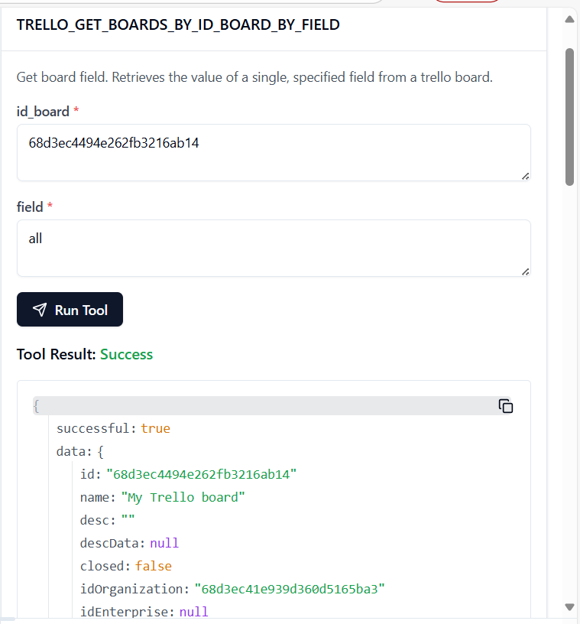

60. **TRELLO_GET_BOARDS_CARDS_BY_ID_BOARD**

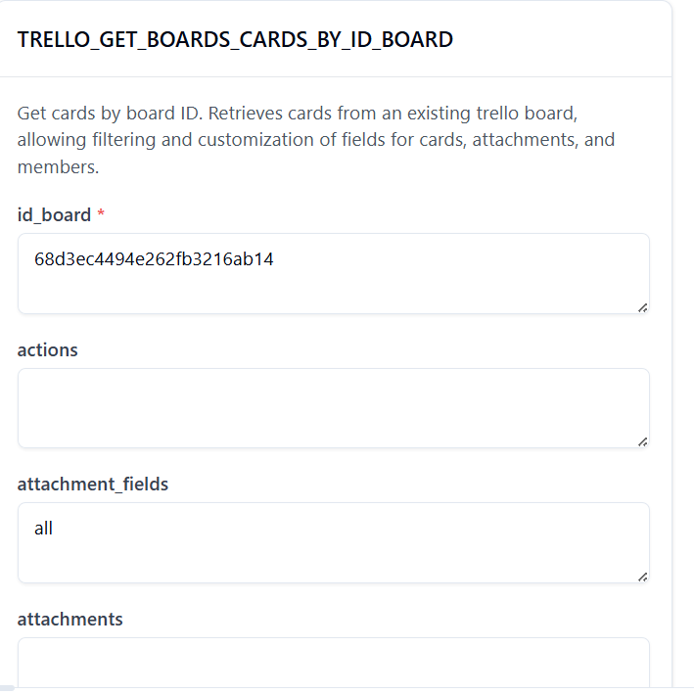

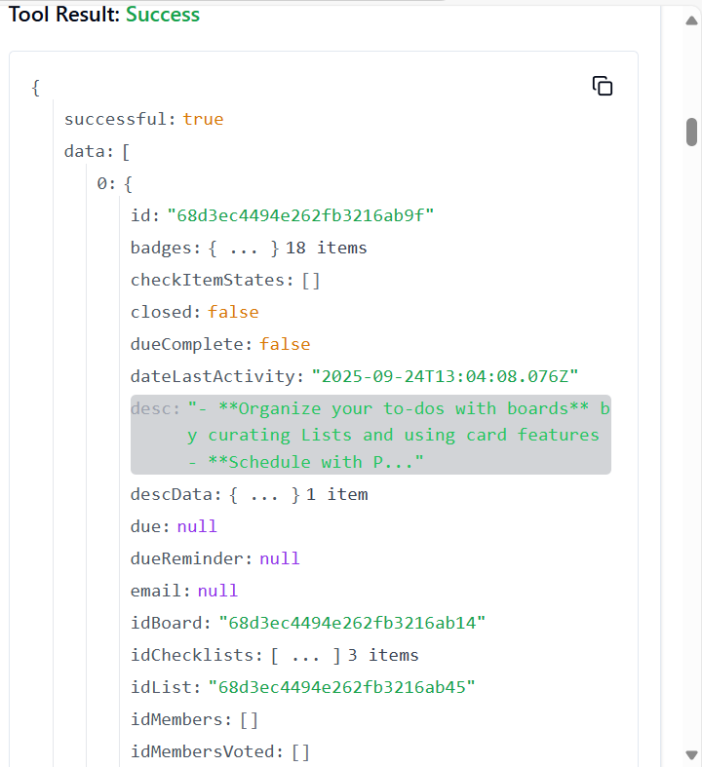

61. **TRELLO_GET_BOARDS_CARDS_BY_ID_BOARD_BY_FILTER**

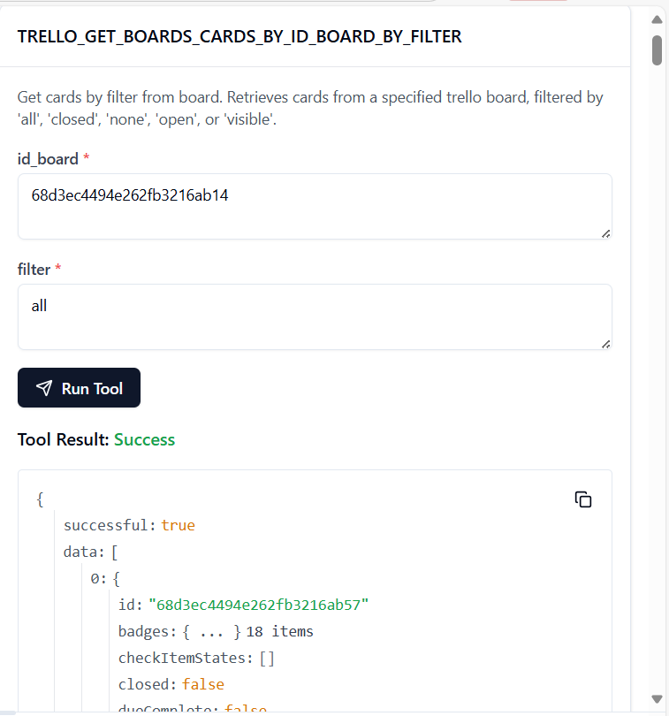

62. **TRELLO_GET_BOARDS_CHECKLISTS_BY_ID_BOARD**

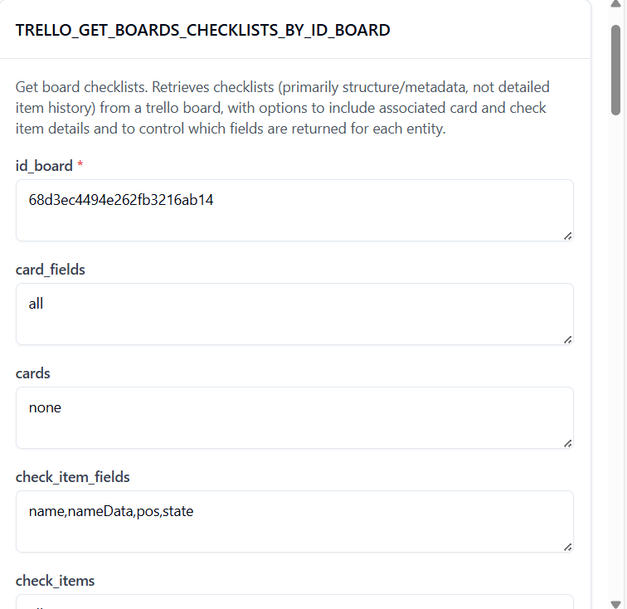

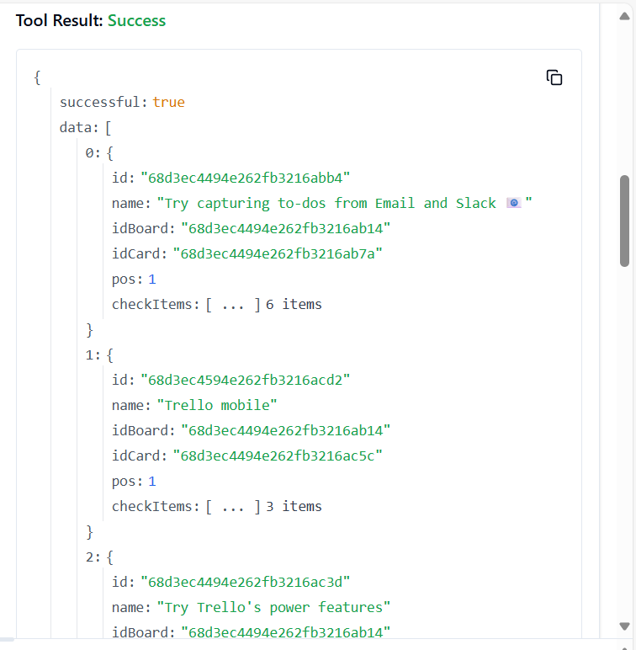

63. **TRELLO_GET_BOARDS_DELTAS_BY_ID_BOARD**

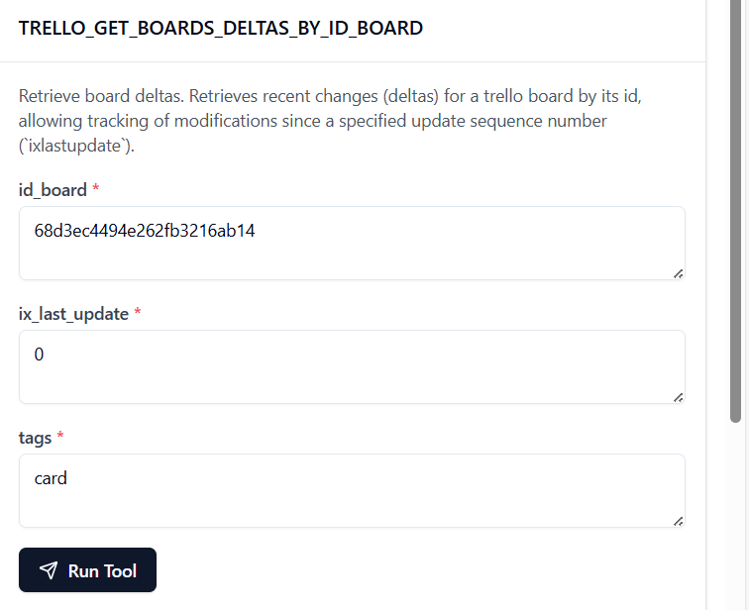

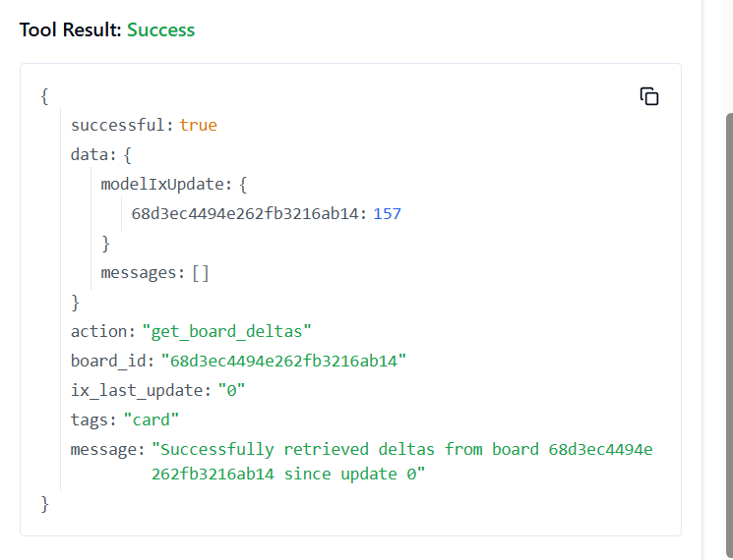

64. **TRELLO_GET_BOARDS_LABELS_BY_ID_BOARD**

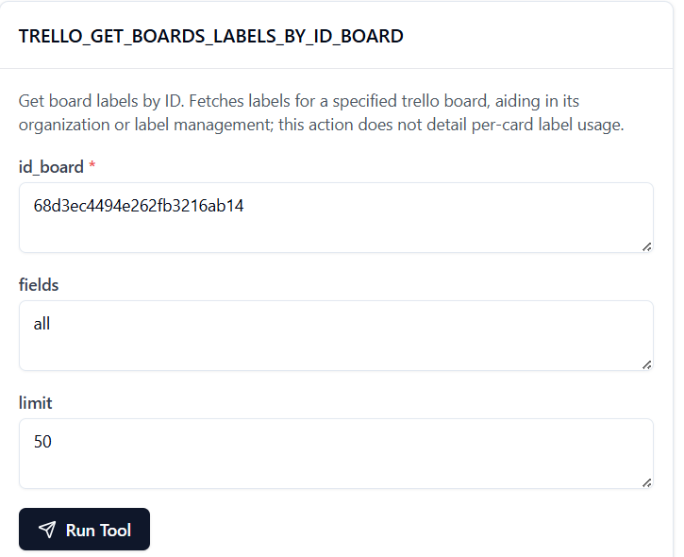

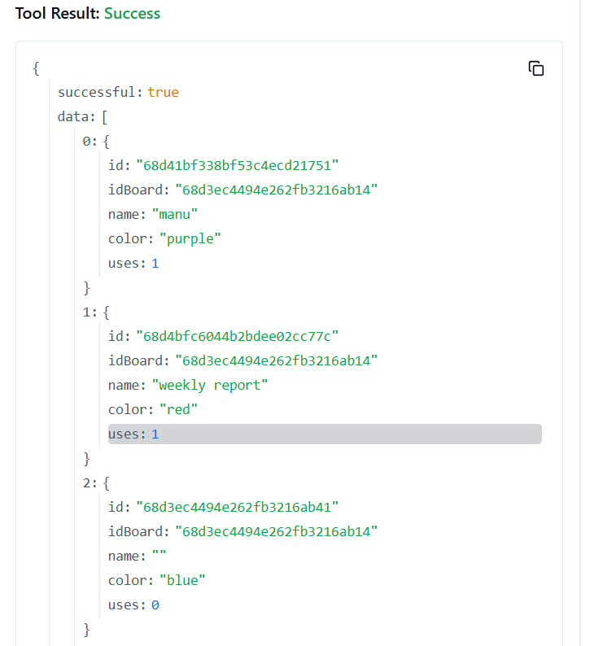

65. **TRELLO_GET_BOARDS_LABELS_BY_ID_BOARD_BY_ID_LABEL**

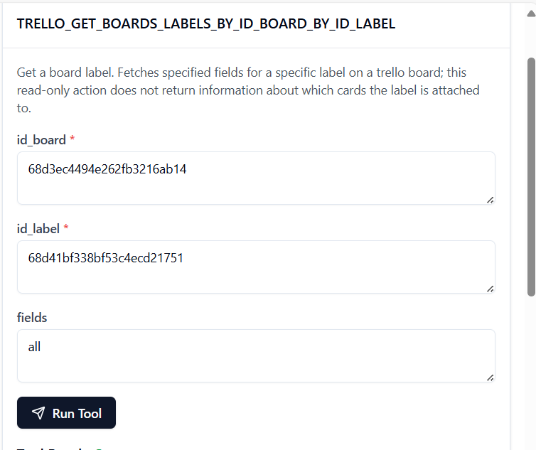

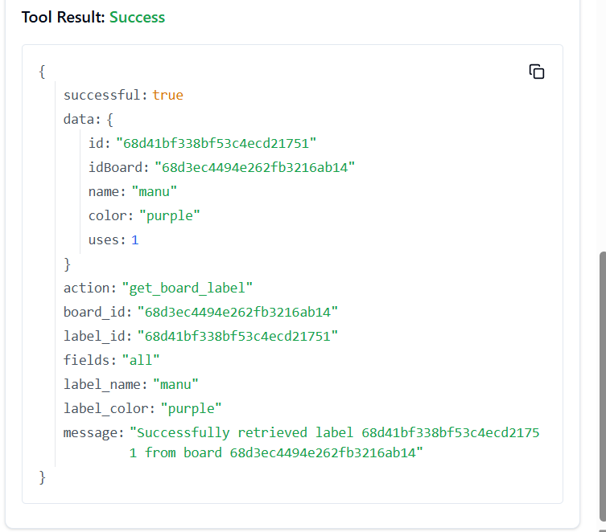

66. **TRELLO_GET_BOARDS_LISTS_BY_ID_BOARD**

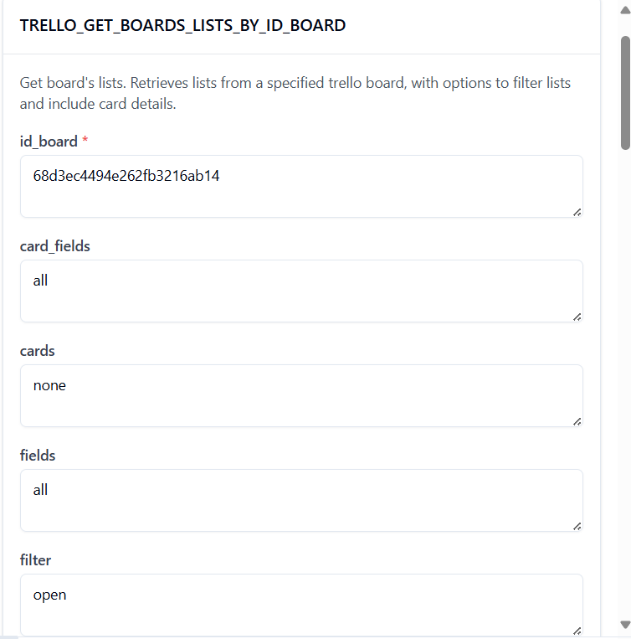

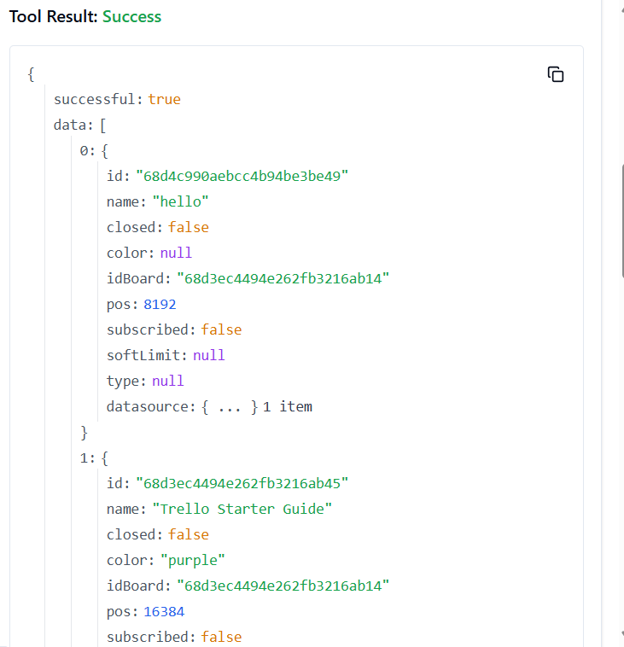

67. **TRELLO_GET_BOARDS_LISTS_BY_ID_BOARD_BY_FILTER**

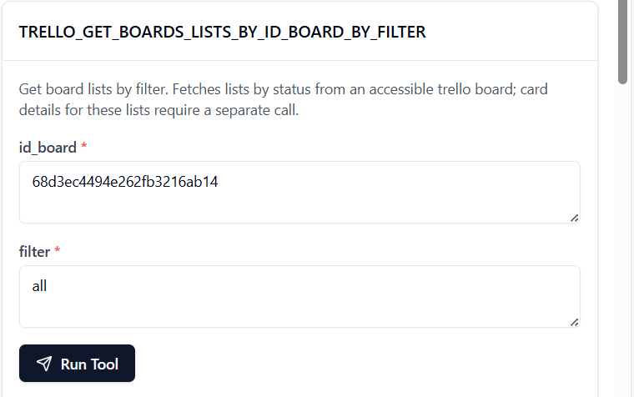

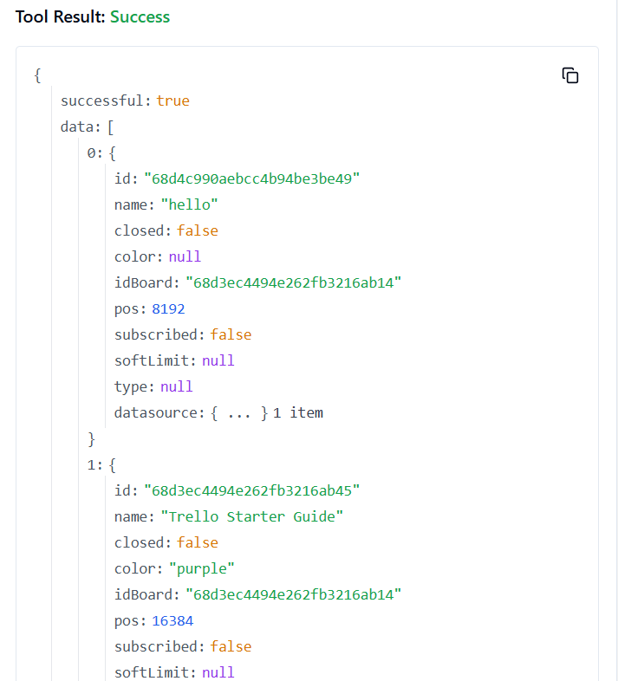

68. **TRELLO_GET_BOARDS_MEMBERS_BY_ID_BOARD**

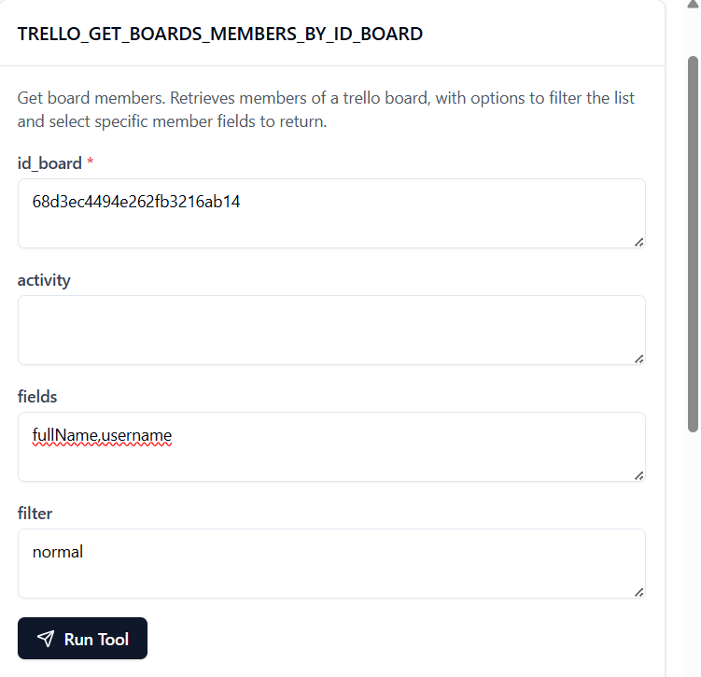

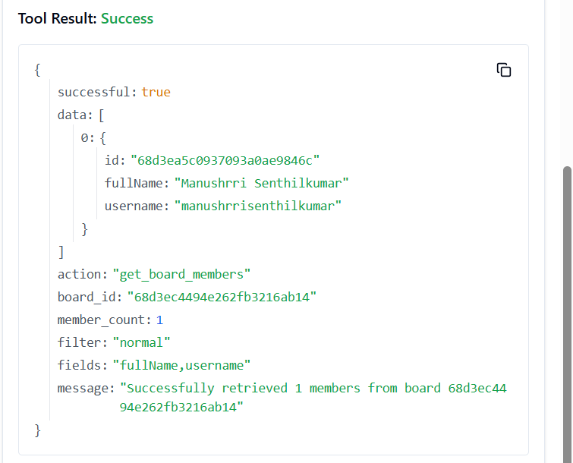

69. **TRELLO_GET_BOARDS_MEMBERS_BY_ID_BOARD_BY_FILTER**

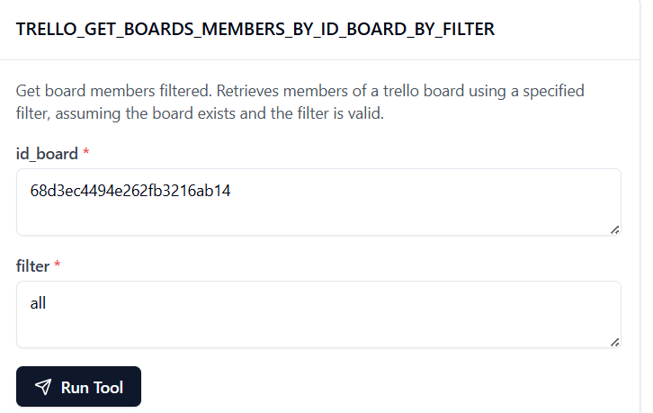

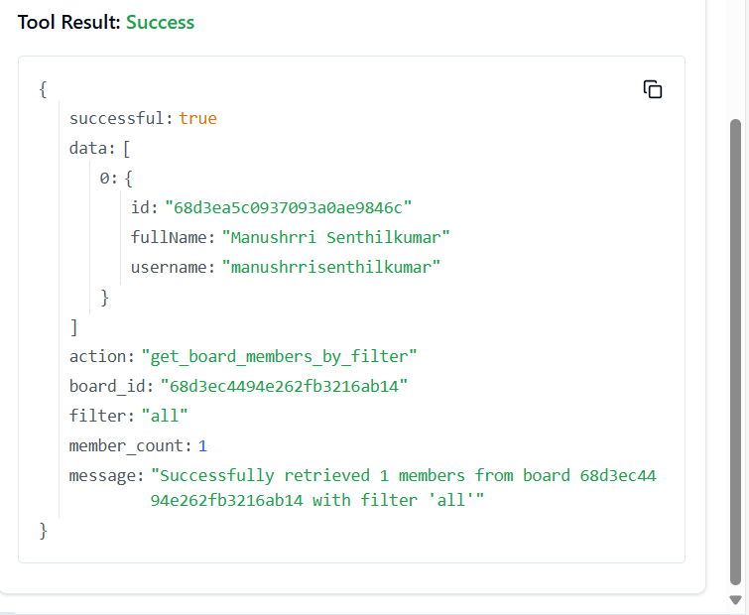

70. **TRELLO_GET_BOARDS_MEMBERSHIPS_BY_ID_BOARD**

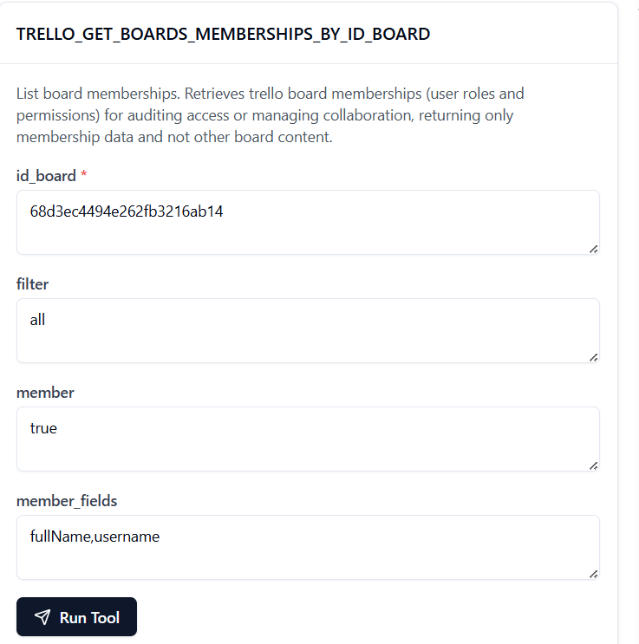

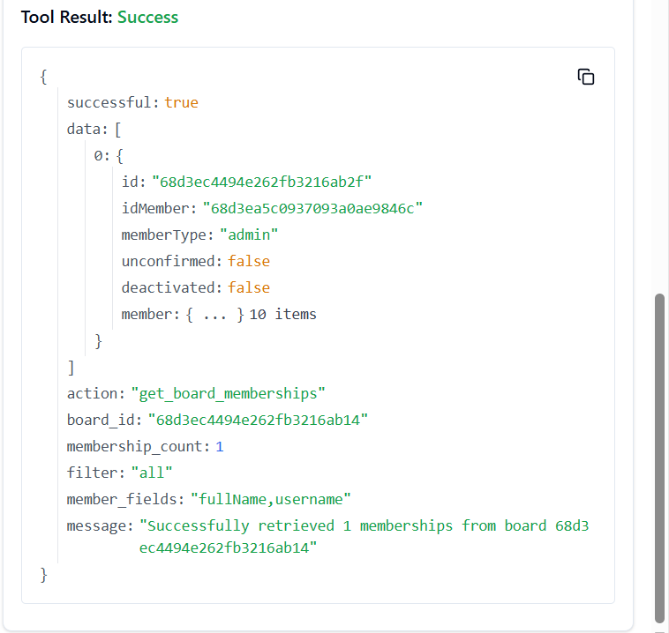

71. **TRELLO_GET_BOARDS_MEMBERSHIPS_BY_ID_BOARD_BY_ID_MEMBERSHIP**

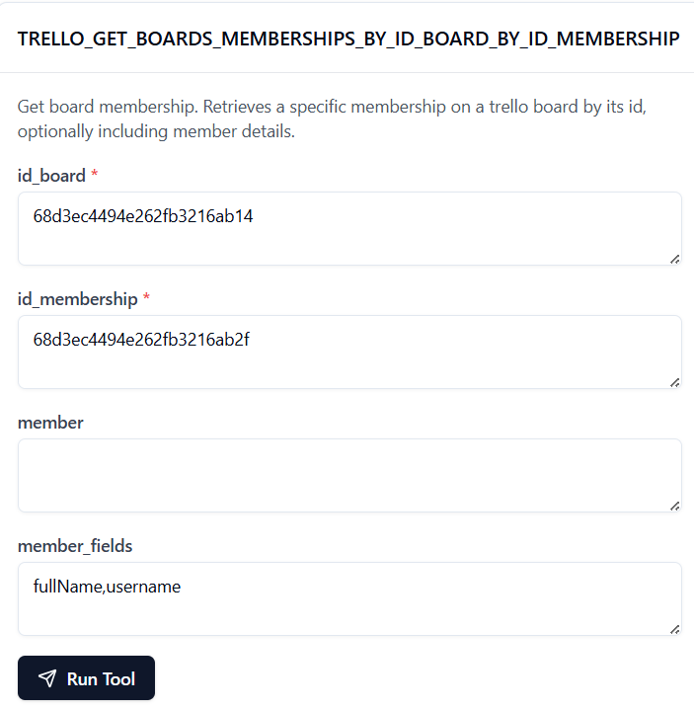

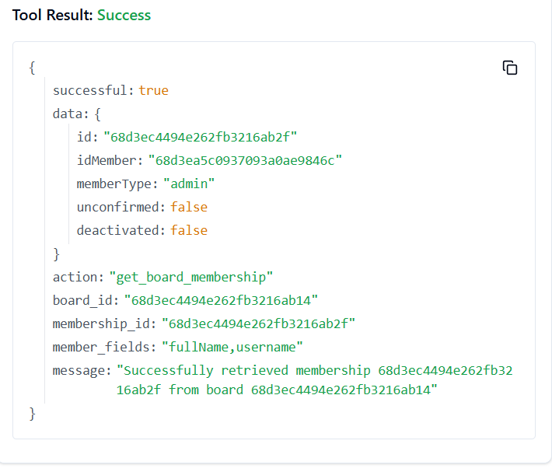

72. **TRELLO_GET_BOARDS_MEMBERS_INVITED_BY_ID_BOARD**

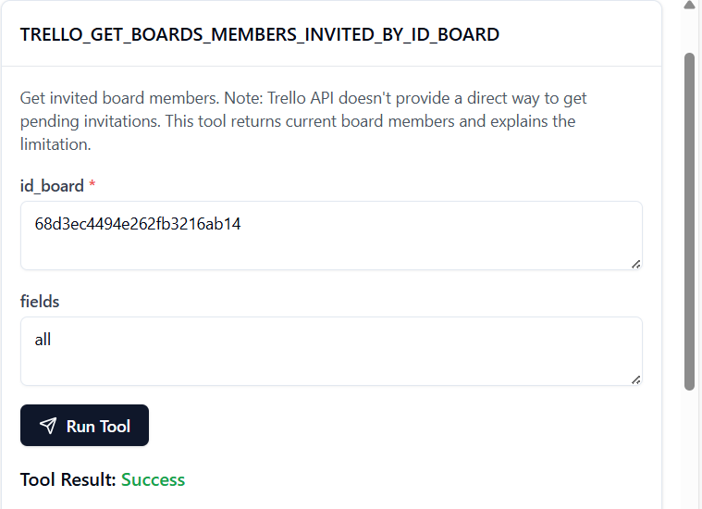

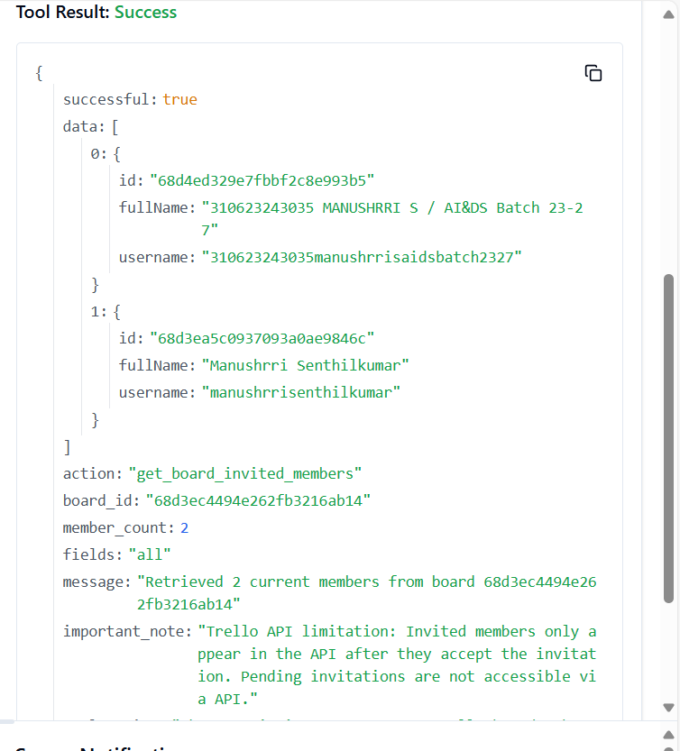

73. **TRELLO_GET_BOARDS_MEMBERS_INVITED_BY_ID_BOARD_BY_FIELD**

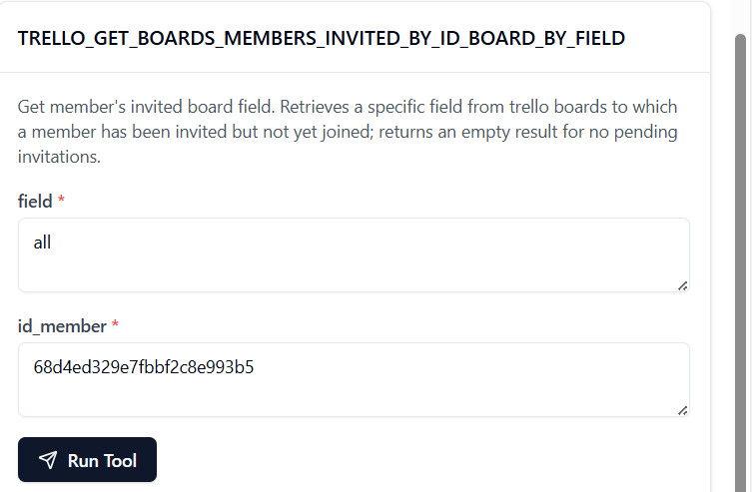

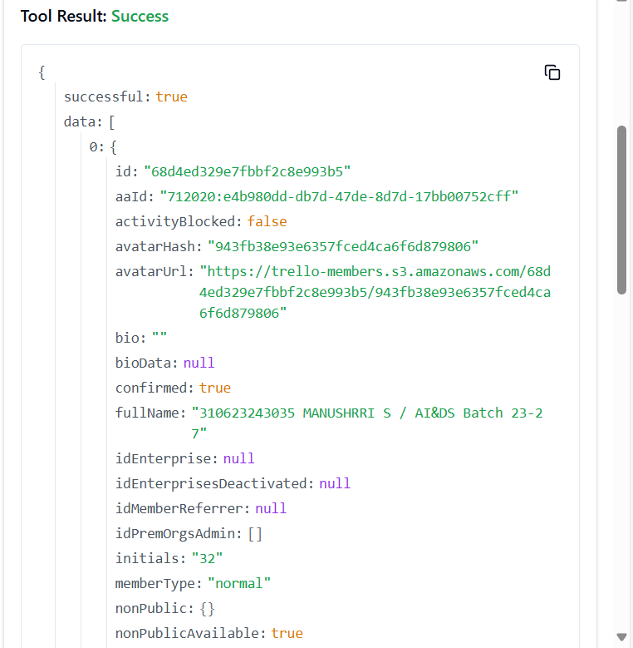

74. **TRELLO_GET_BOARDS_MY_PREFS_BY_ID_BOARD**

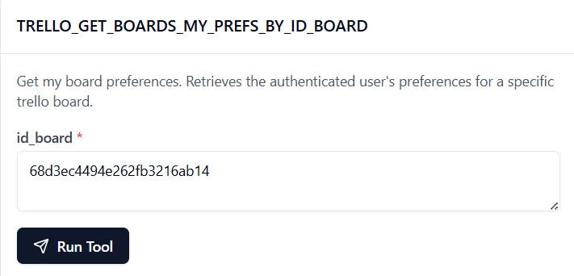

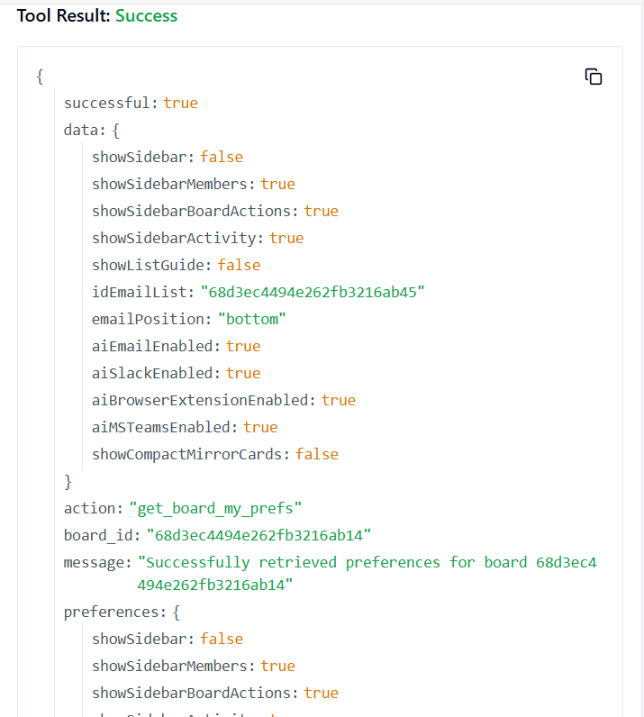

75. **TRELLO_GET_BOARDS_ORGANIZATION_BY_ID_BOARD**

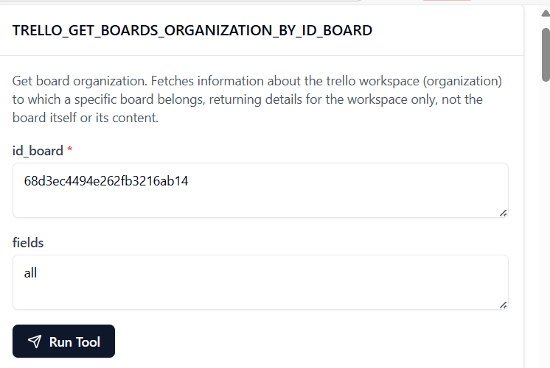

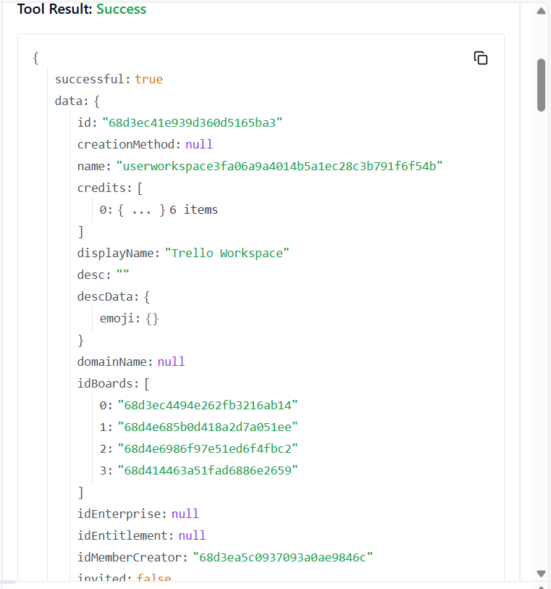

76. **TRELLO_GET_BOARDS_ORGANIZATION_BY_ID_BOARD_BY_FIELD**

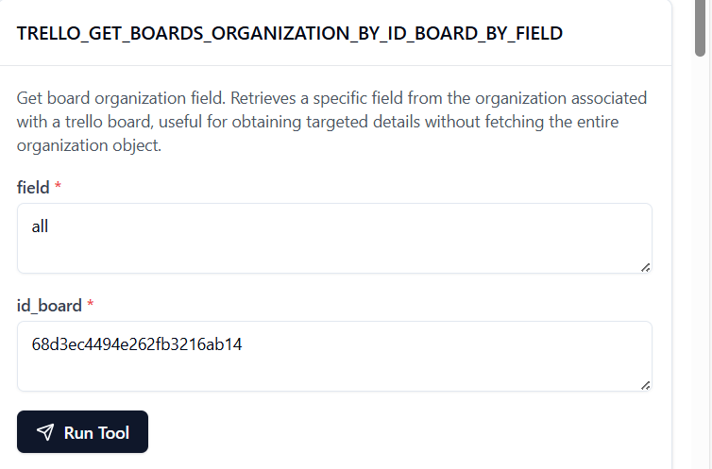

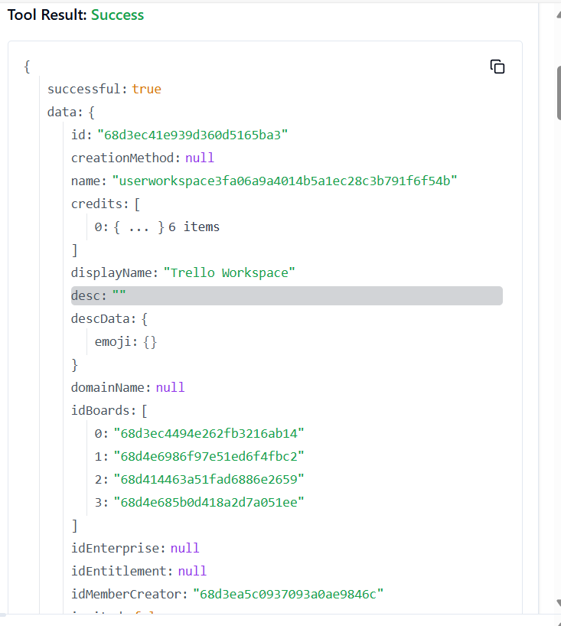

77. **TRELLO_GET_CARDS_ACTIONS_BY_ID_CARD**

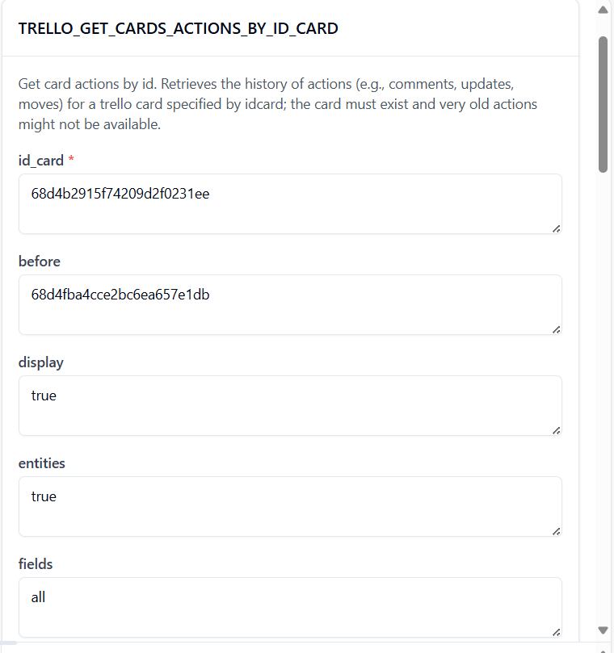

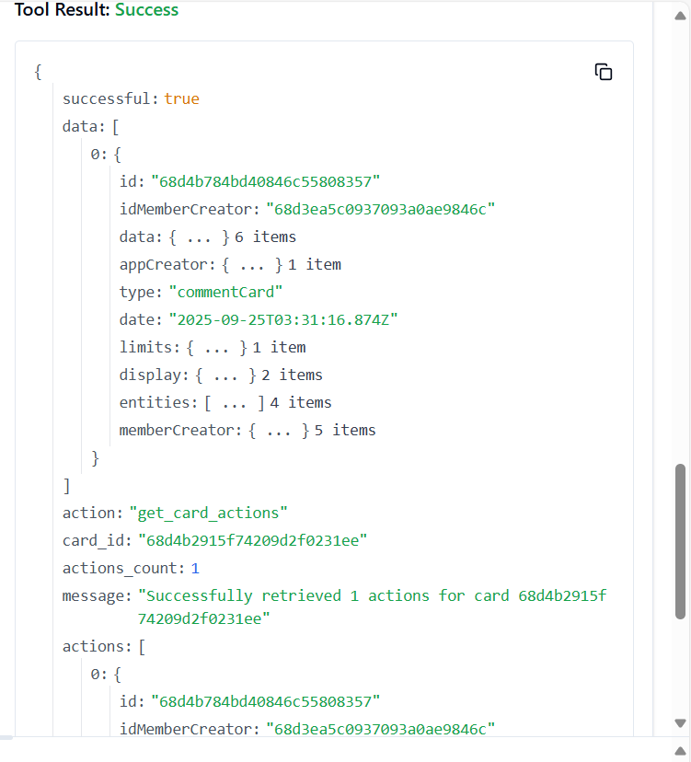

78. **TRELLO_GET_CARDS_ATTACHMENTS_BY_ID_CARD**

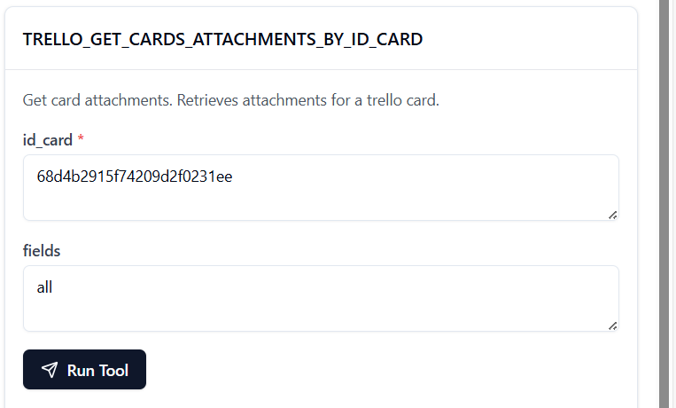

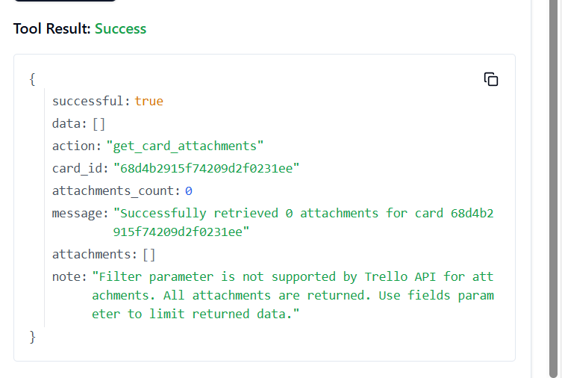

79. **TRELLO_GET_CARDS_BOARD_BY_ID_CARD**

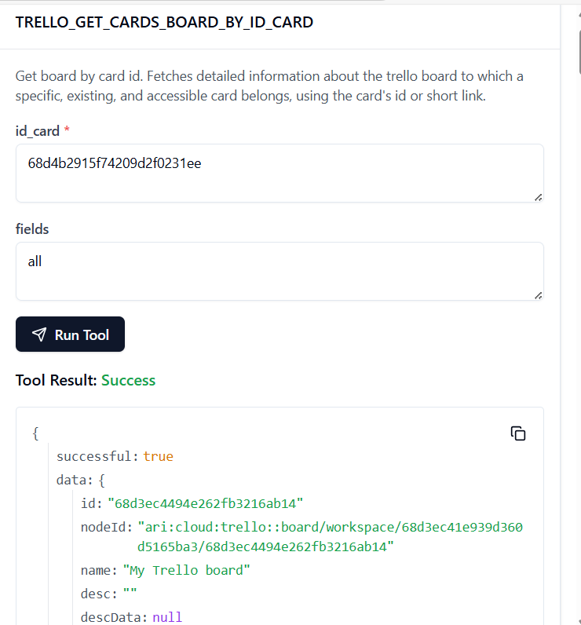

80. **TRELLO_GET_CARDS_BOARD_BY_ID_CARD_BY_FIELD**

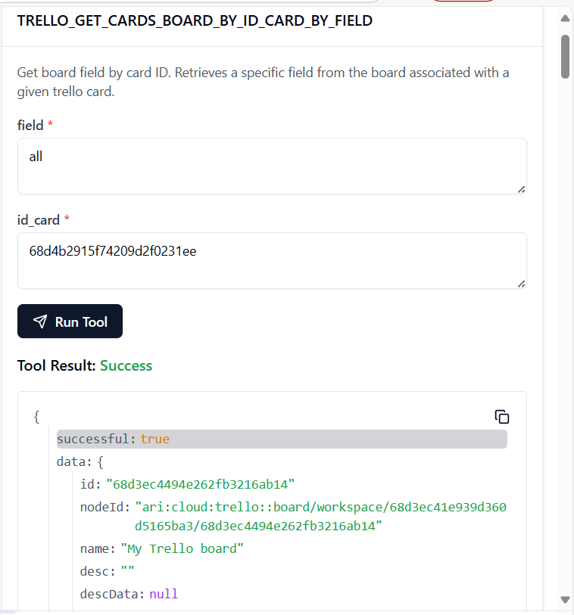

81. **TRELLO_GET_CARDS_BY_ID_CARD_BY_FIELD**

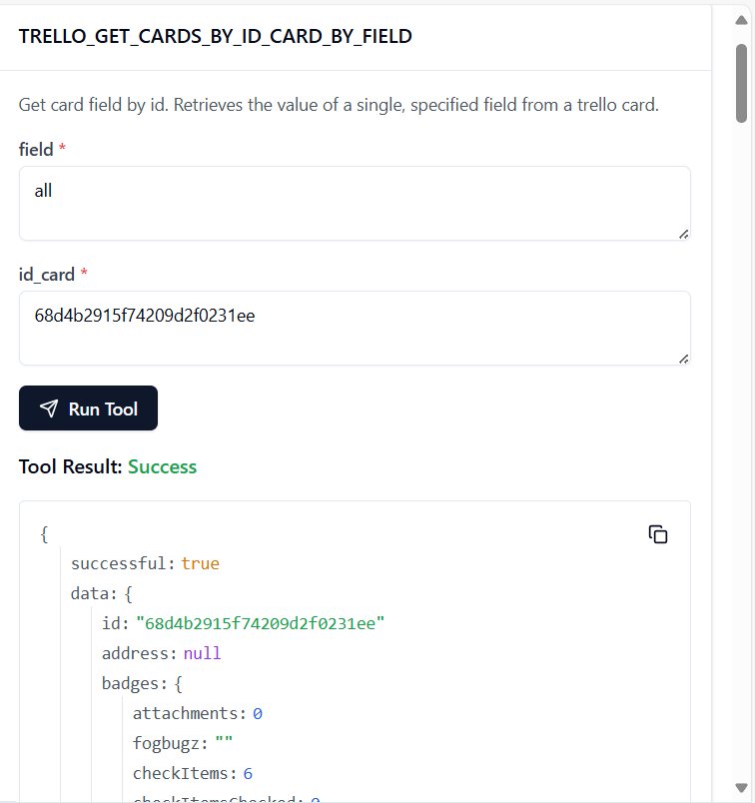

**82. TRELLO_GET_CARDS_CHECK_ITEM_STATES_BY_ID_CARD**

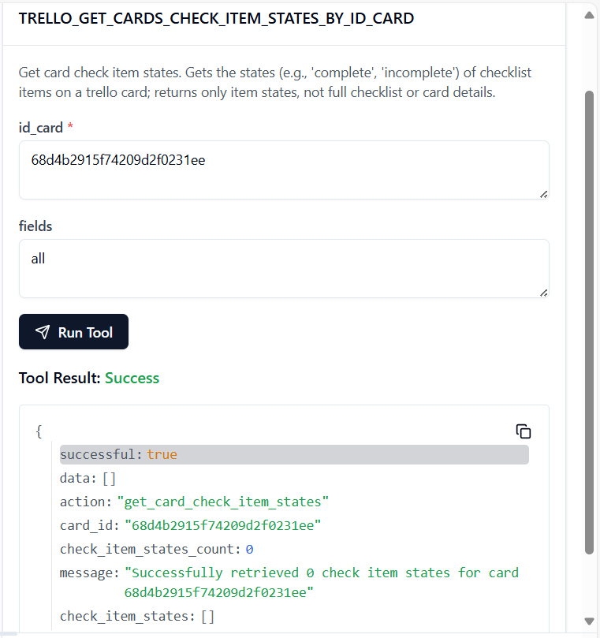

**83. TRELLO_GET_CARDS_CHECKLISTS_BY_ID_CARD**

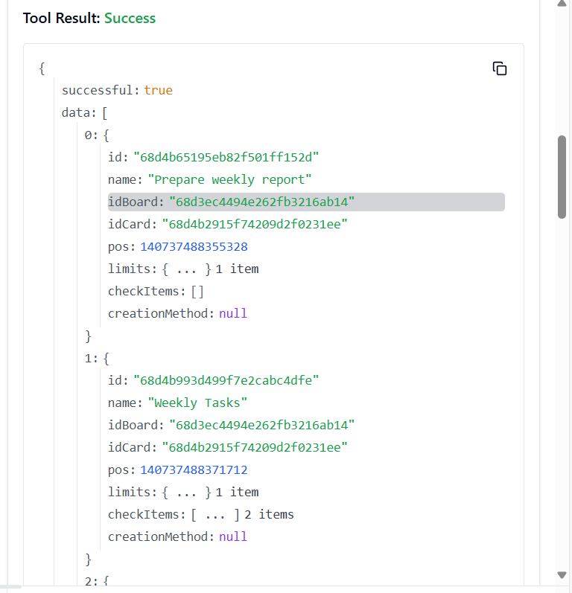

**84. TRELLO_GET_CARDS_LIST_BY_ID_CARD**

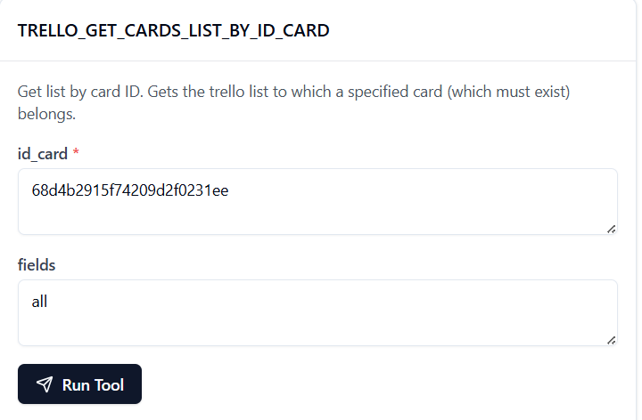

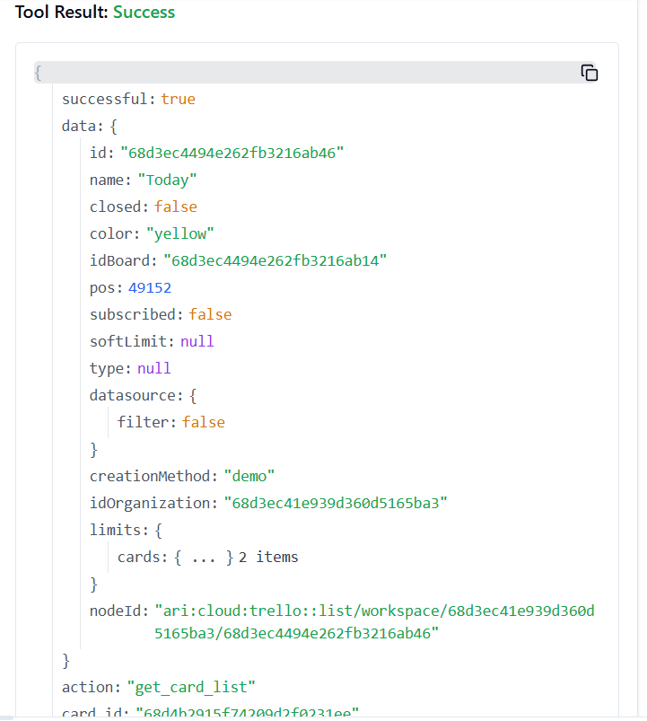

**85. TRELLO_GET_CARDS_BOARD_BY_ID_CARD_BY_FIELD**

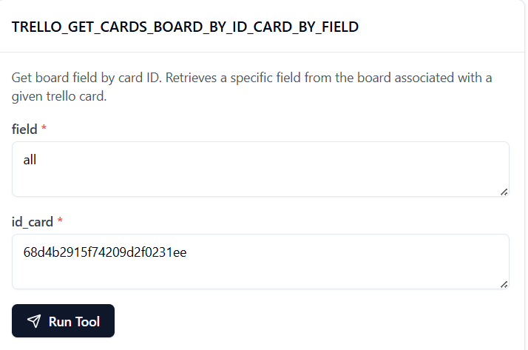

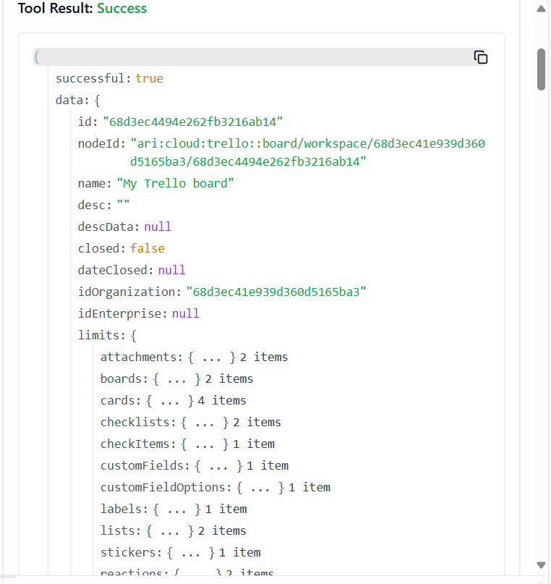

**86. TRELLO_GET_CARDS_MEMBERS_BY_ID_CARD**

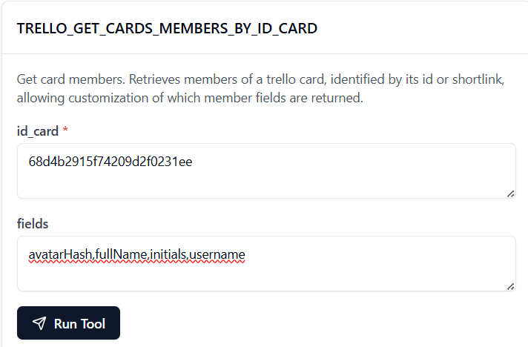

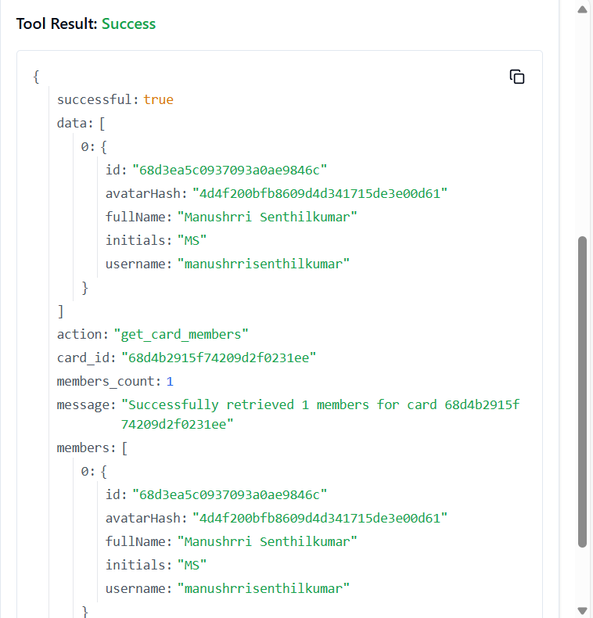

**87. TRELLO_GET_CARDS_MEMBERS_VOTED_BY_ID_CARD**

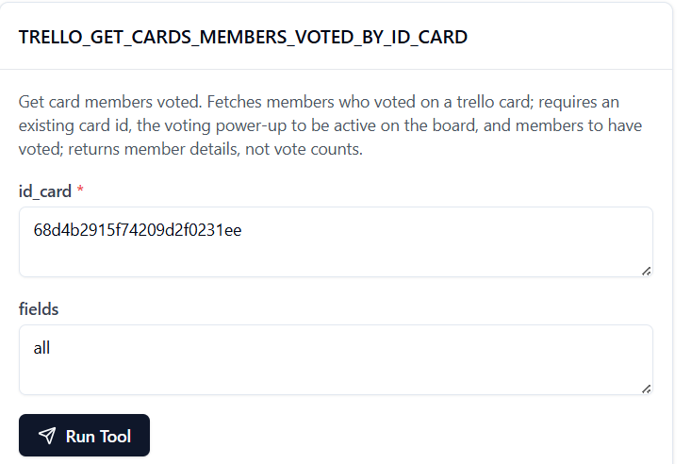

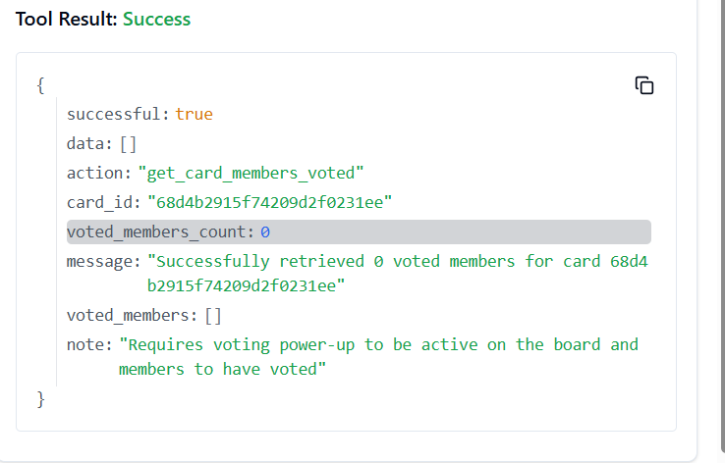

**88. TRELLO_GET_CARDS_STICKERS_BY_ID_CARD**

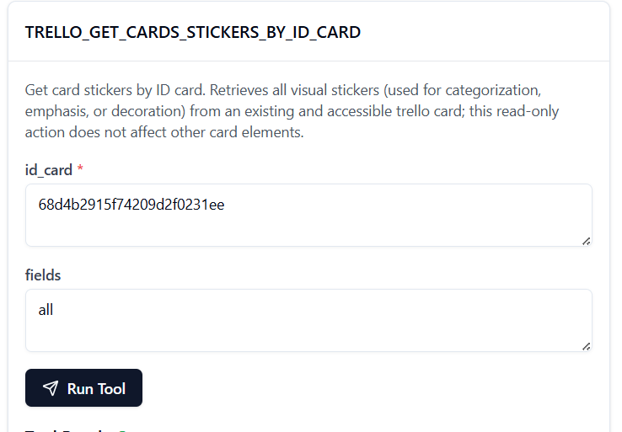

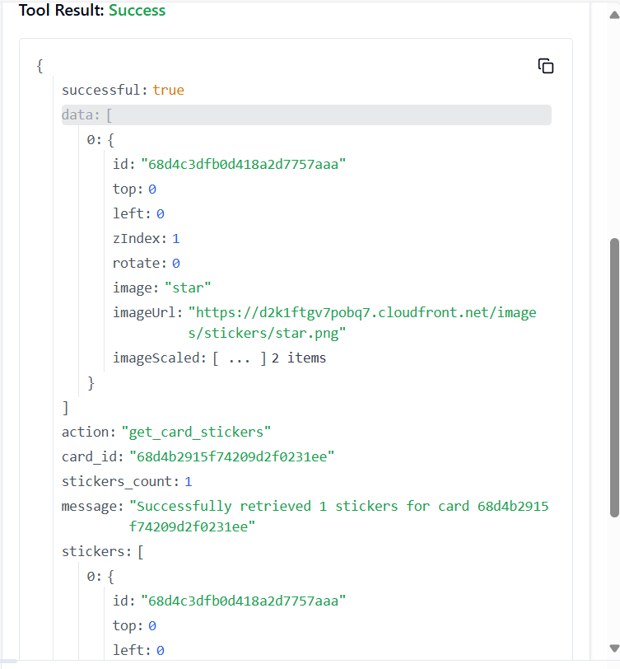

**89. TRELLO_GET_CARDS_STICKERS_BY_ID_CARD_BY_ID_STICKER**

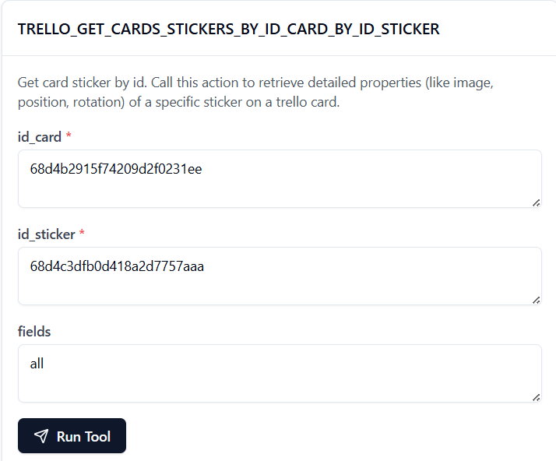

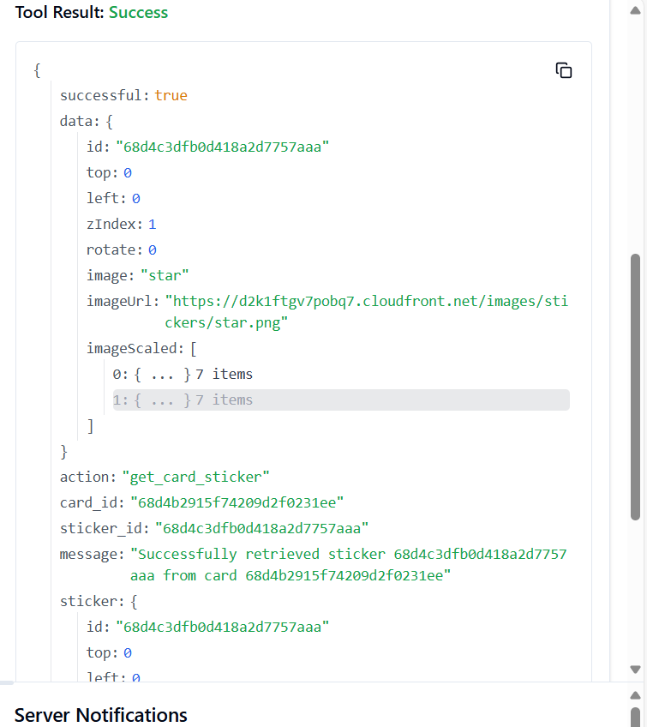

**90. TRELLO_GET_CHECK_ITEM_BY_ID**

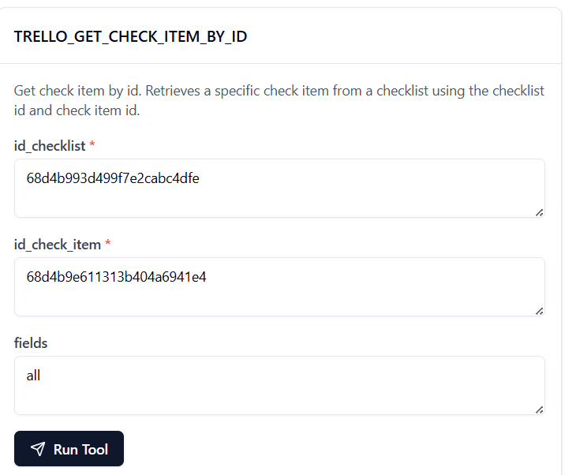

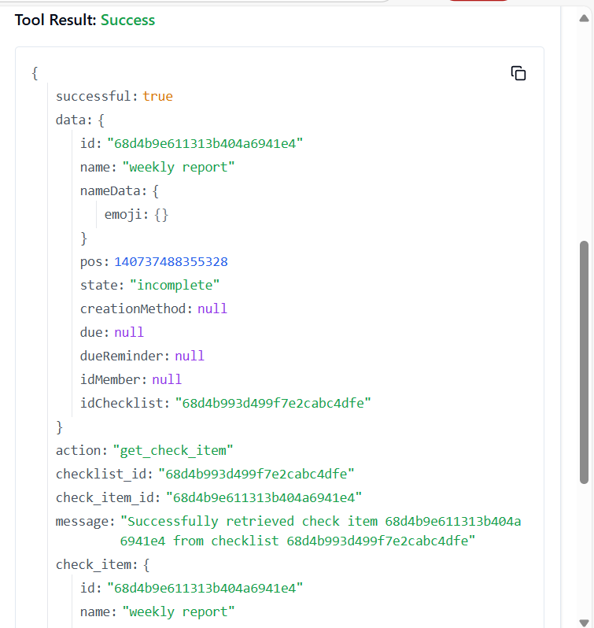

**91. TRELLO_GET_CHECKLISTS_BOARD_BY_ID_CHECKLIST**

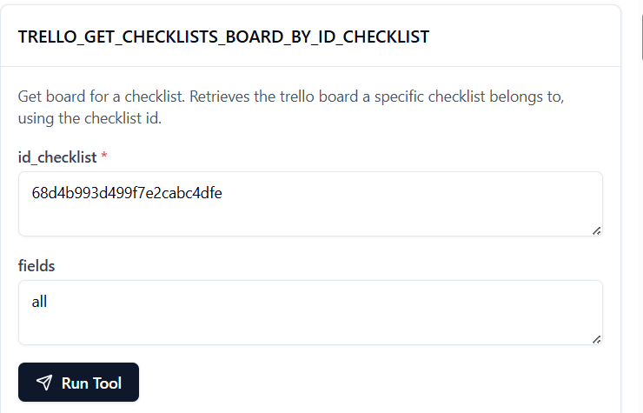 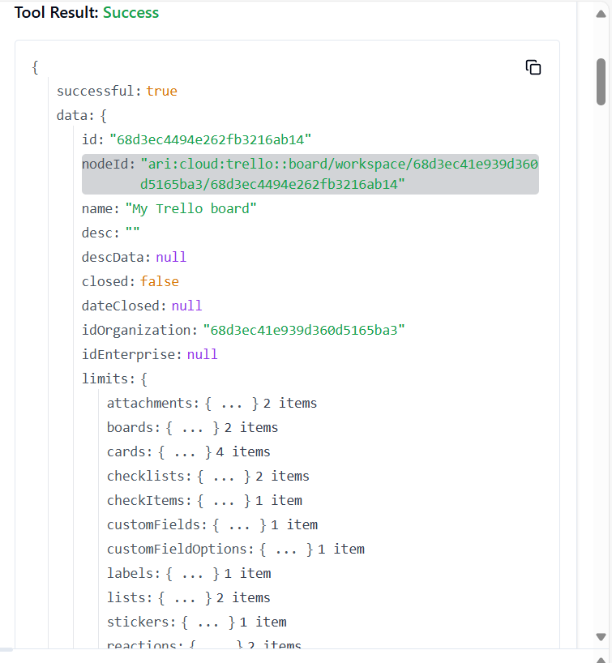

92. **TRELLO_GET_CHECKLISTS_BOARD_BY_ID_CHECKLIST_BY_FIELD**

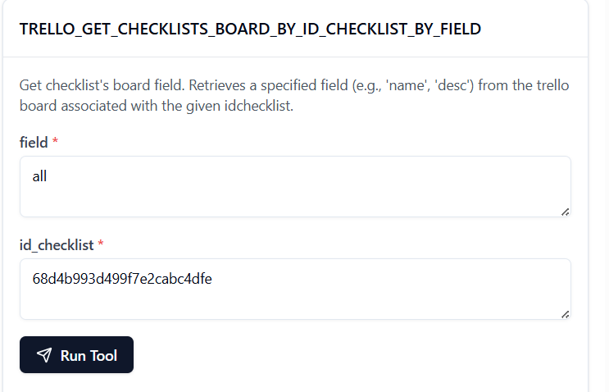

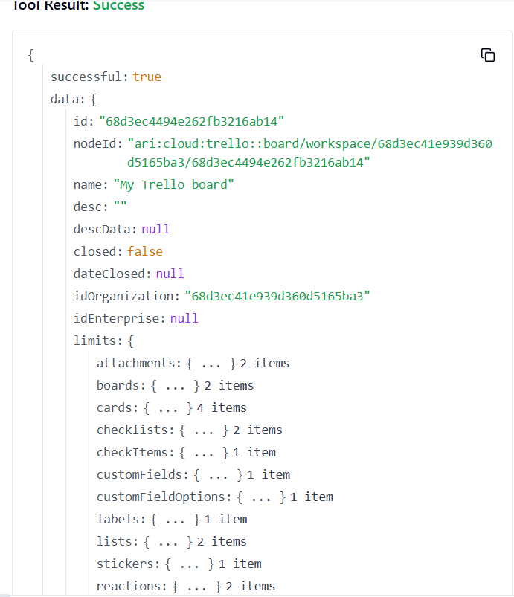

93. **TRELLO_GET_CHECKLISTS_BY_ID_CHECKLIST**

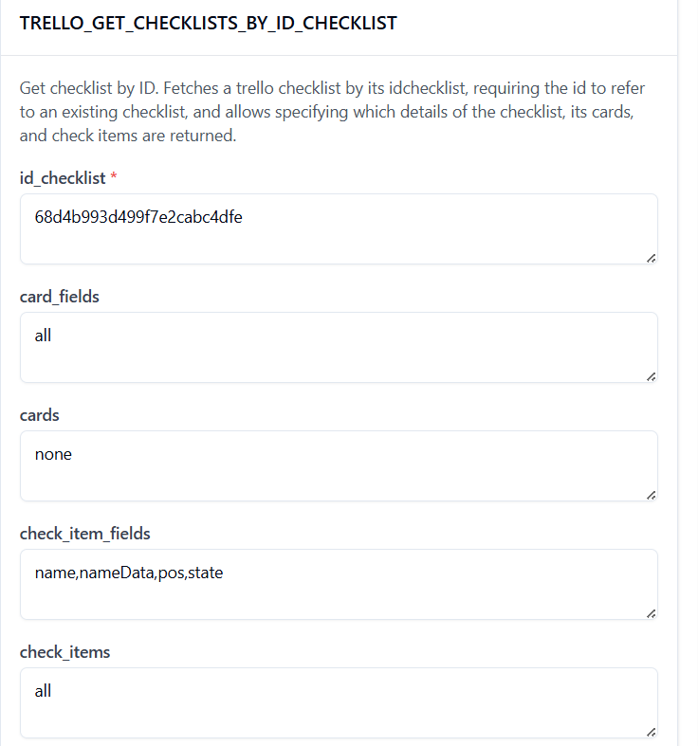

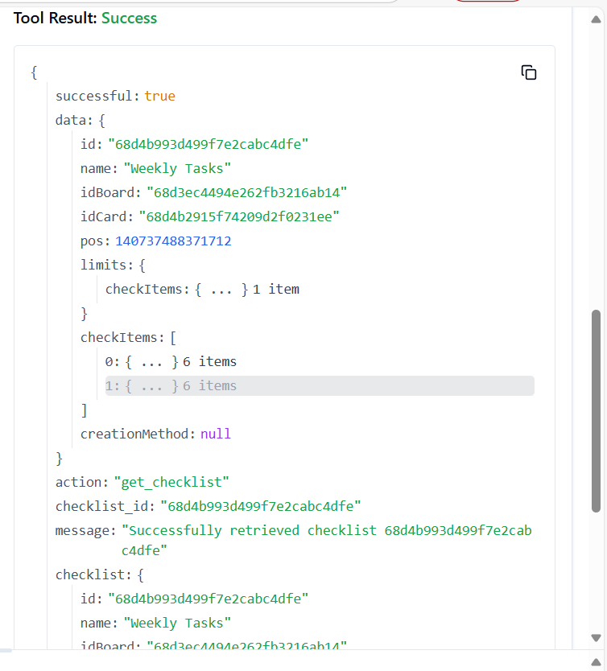

**94. TRELLO_GET_CHECKLISTS_BY_ID_CHECKLIST_BY_FIELD**

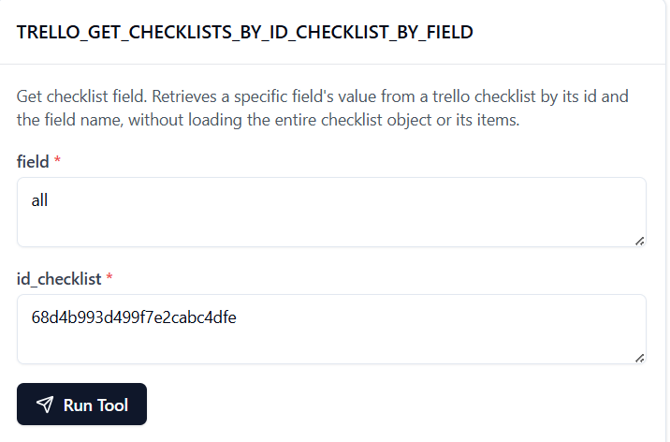

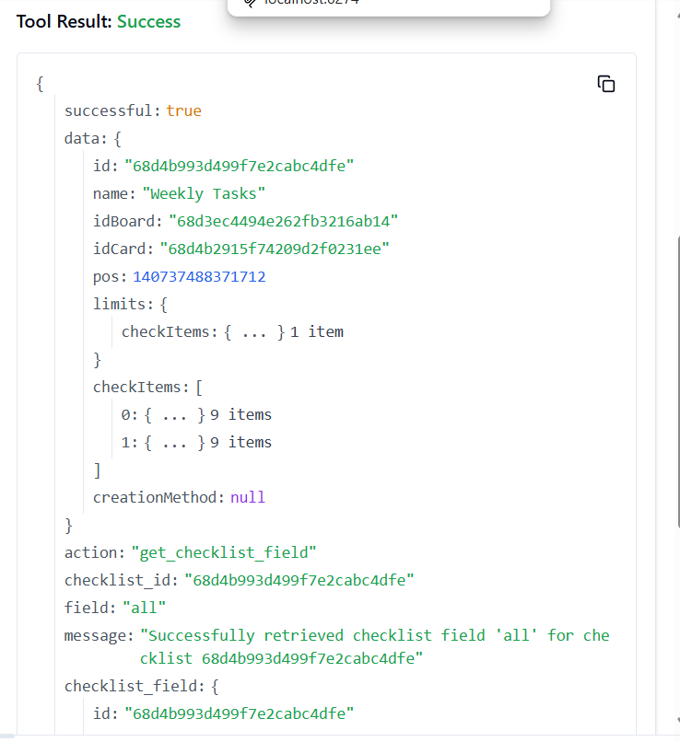

**95. TRELLO_GET_CHECKLISTS_CARDS_BY_ID_CHECKLIST_BY_FILTER**

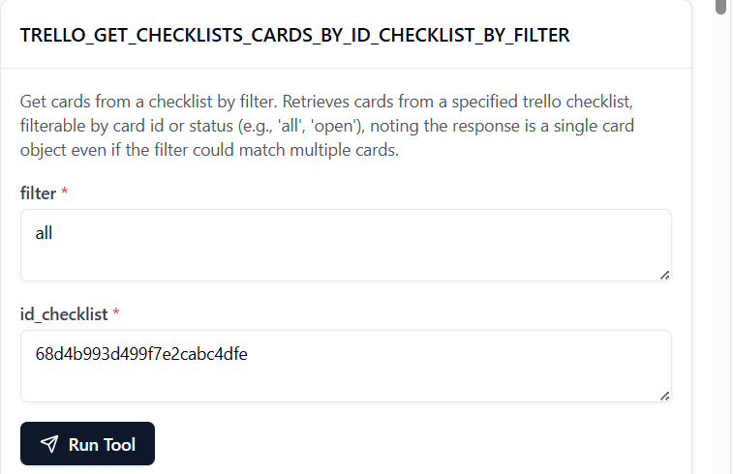

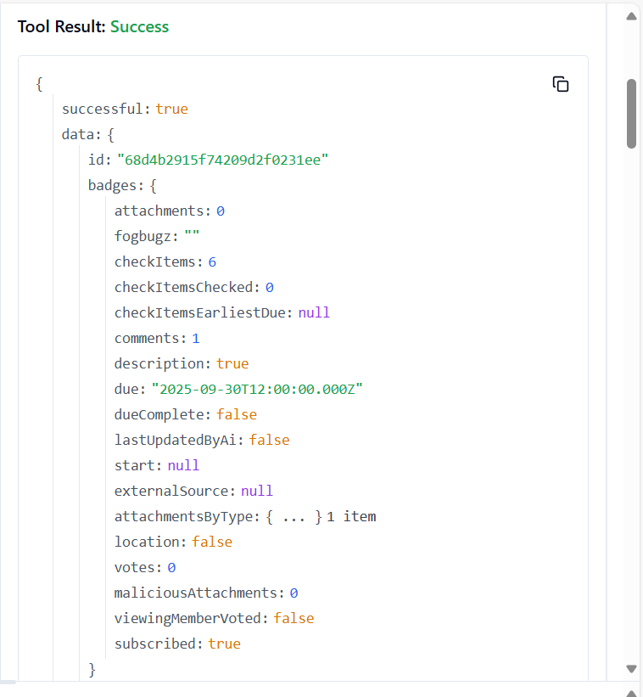

**96. TRELLO_GET_CHECKLISTS_CHECK_ITEMS_BY_ID_CHECKLIST**

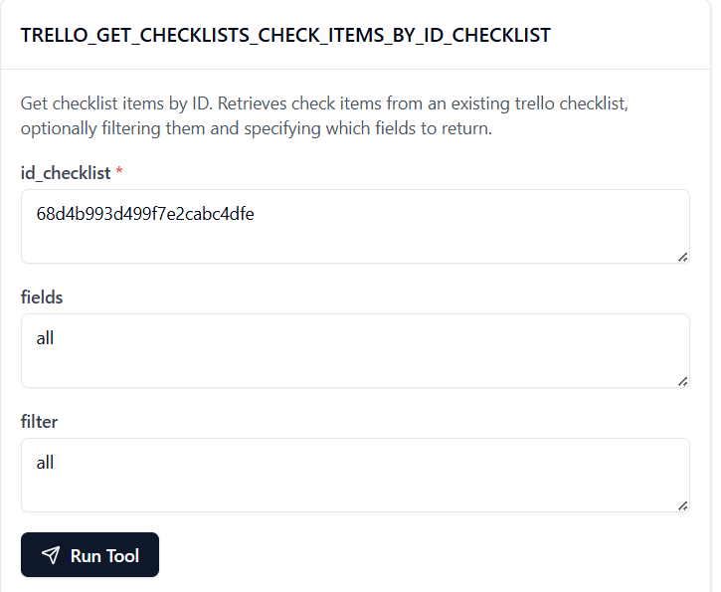

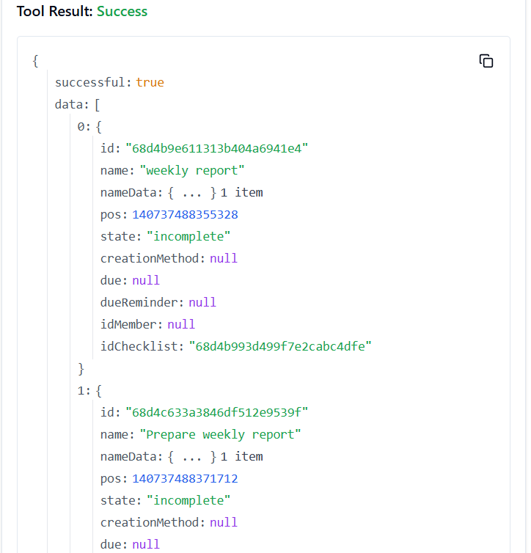

**97. TRELLO_GET_LABELS_BOARD_BY_ID_LABEL**

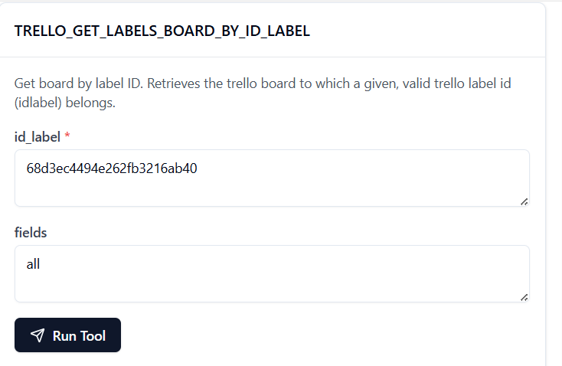

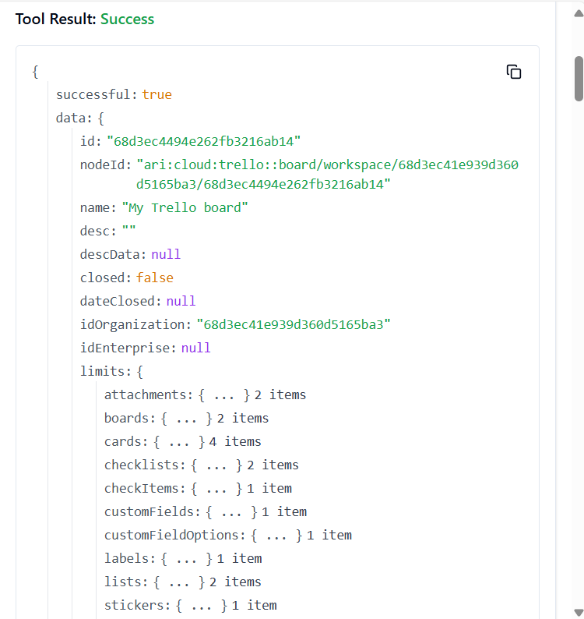

**98. TRELLO_GET_LABELS_BOARD_BY_ID_LABEL_BY_FIELD**

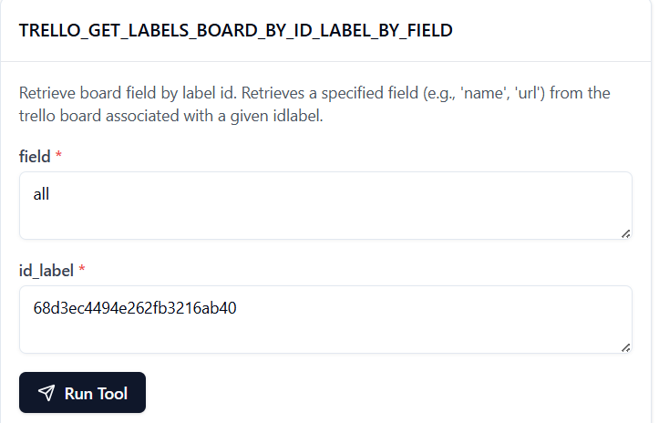

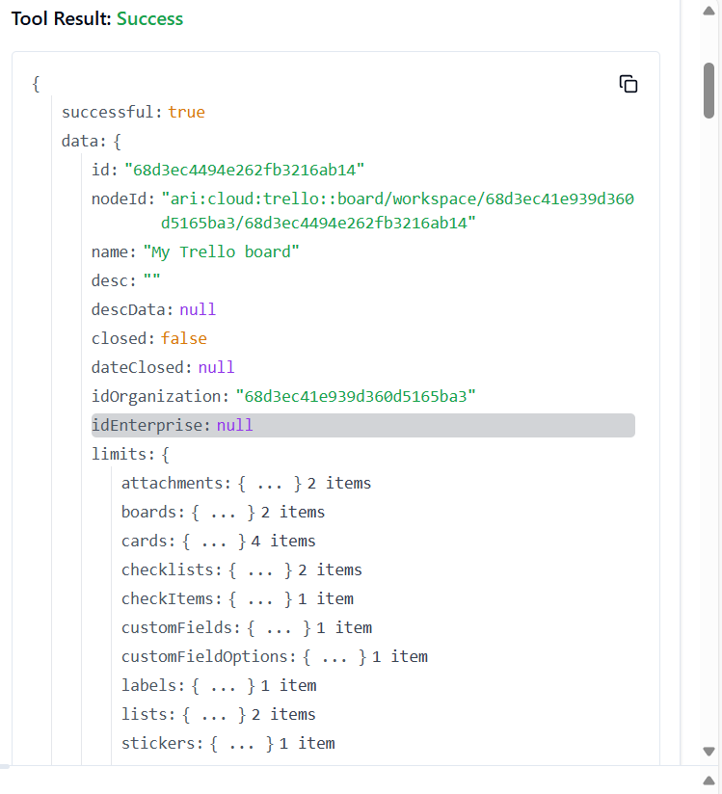

**99. TRELLO_GET_LABELS_BY_ID_LABEL**

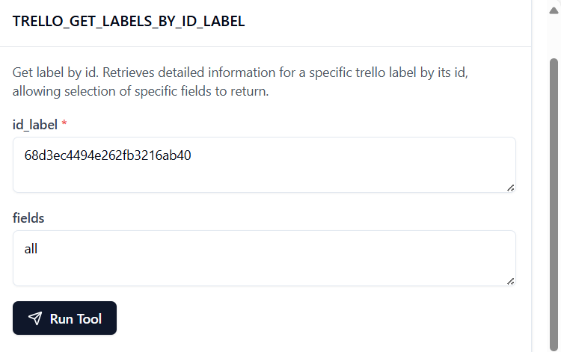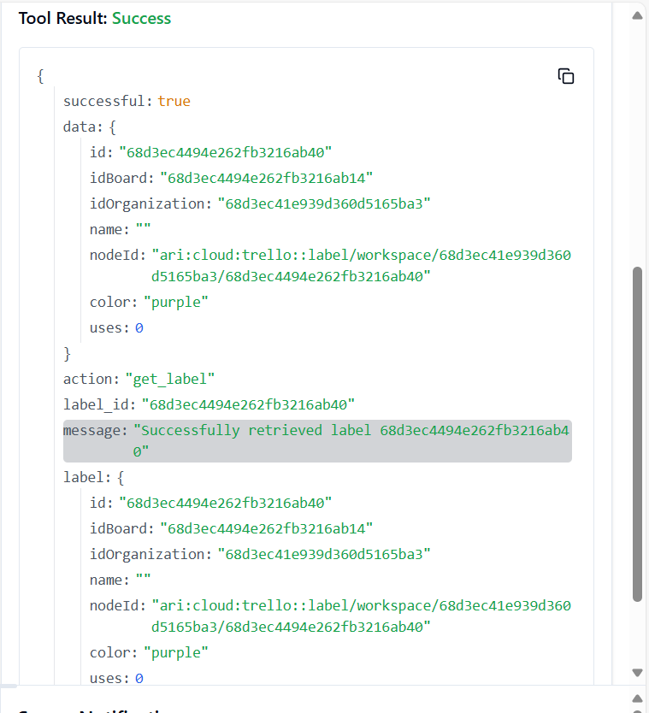

**100. TRELLO_GET_LISTS_ACTIONS_BY_ID_LIST**

